
June 2015

FALKIRK COUNCIL

Air Quality Management Action Plan (Falkirk Town Centre and Haggs)

Submitted to:
Falkirk Council Abbotsford House Falkirk
FK2 7YZ

Report Number. 11514880001.501/B.2
REPORT
Distribution:

Falkirk Council - 1 copy (pdf) Golder Associates - 1 copy (pdf)

Executive Summary

The 1995 Environment Act and subsequent regulations made there under require Falkirk Council to produce an action plan to address air quality in their area. This follows on from the declaration of four Air Quality Management Areas (AQMAs) for potential exceedance of national objectives in relation to annual mean nitrogen dioxide (NO₂) and particulate matter (PM₁₀) concentrations. Falkirk Council has declared the following AQMAs:
- An AQMA in Grangemouth, for the 15-minute sulphur dioxide (SO₂) objective;
- An AQMA in Falkirk Town Centre, covering the annual mean NO₂ objective and Scottish PM₁₀ daily and annual objectives;
- An AQMA in Haggs, for the annual mean NO₂ objective; and
- An AQMA in Banknock, for a breach of the Scottish PM₁₀ and a potential breach of the UK PM₁₀ objectives.
This Air Quality Action Plan (AQAP) focuses only on the Falkirk Town Centre and Haggs AQMAs with the other AQMAs dealt with under other AQAPs. This AQAP intends to show how the Council, in partnership with the community and other stakeholders, will improve air quality in the Falkirk Council area. Because of the nature of the challenge facing Falkirk Council many of the actions contained are long term goals rather than attempts at short term fixes.
This draft AQAP has been the product of extensive internal consultation through the steering group which has consisted of a number of interested parties within the Council and reflects the views and comments of all stakeholders. The actions detailed in the plan reflect the outcome of our consultations. They also aim to integrate, as far as possible, with existing local and national plans and strategies relating to key issues such as transport and development.
The plan currently sets out 20 actions that have been identified to reduce pollutant levels of both NO₂ and PM₁₀ within Falkirk. The actions are Council wide measures that will directly improve air quality throughout Falkirk and not just in the AQMAs. These actions aim to strike an appropriate balance between the direct and indirect costs of taking action and the benefit in terms of improved air quality. The types of actions set out in the plan are:
- Reducing emissions from individual vehicles;
- Promotion of ECO Stars;
- Planning and development measure;
- Reducing demand for travel and promoting alternative modes of transport; and
- Educate and inform the public regarding air quality.
The plan also provides an evaluation of the actions detailed and the potential they bring to addressing Air Quality in Falkirk. Monitoring and re-evaluating these actions will be the key to the long term success of the Action Plan.

Table of Contents

  - INTRODUCTION 1
  - Council Area 1
  - Applicable Air Quality Objectives 2
  - Local Air Quality Management 3
  - HEALTH IMPACTS OF ATMOSPHERIC POLLUTION 5
  - Atmospheric Pollution 6
    - Particulate Matter (PM) 6
    - Oxides of Nitrogen (NOX) 6
    - Sulphur Dioxide (SO2) 7
    - Ozone (O3) 7
  - Summary of Health Effects of pollutants in the Air 7
  - Air Pollution Indexes 7
  - AIR QUALITY IN FALKIRK 9
  - Background Pollutant Concentrations 9
    - NO2 9
    - PM10 9
  - Monitored Concentrations 12
    - NO2 12
      - Falkirk Town Centre AQMA 12
      - Haggs AQMA 13
    - PM10 17
  - Emissions Inventory 18
    - Falkirk Town Centre AQMA NAEI Emissions Totals 19
    - Haggs AQMA NAEI Emissions Totals 21
  - Source Apportionment 22
    - Haggs 22
    - Falkirk Town Centre 24
  - POLICIES, PLANS AND DEVELOPMENTS LIKELY TO IMPACT ON THE COUNCILS AIR QUALITY
ACTION PLAN 28
  - Roads and Transportation Policies and Plans 28
    - National Transport Strategy 28
    - Regional Transport Strategy 28
    - Falkirk’s Local Transport Strategy 29
  - Planning and Development Policies and Plans 29
    - Falkirk Local Development Plan 31
  - Corporate Policies and Plans 31
    - Single Outcome Agreement 31
    - Falkirk Council Strategic Community Plan 2010 - 2015 32
    - Falkirk Council Corporate Plan 32
    - Service Improvement Plan 32
  - Sustainable Development / Climate Change Policies and Plans 33
    - Climate Change (Scotland) Act 2009 33
  - Falkirk Council Carbon Management Plan 33
  - Air Quality and Climate Change 36
    - Universal Home Insulation Scheme 38
    - Home Energy Strategy 2008 - 2011 38
    - Zero Waste Strategy 38
  - PLANNED DEVELOPMENTS AFFECTING THE AQMA’S 39
  - Falkirk AQMA 39
  - Haggs AQMA 39
    - Banknock Quarry 39
    - Residential development 39
  - ASSESSING AIR QUALITY IMPROVEMENTS 40
  - Required Air Quality Improvement 40
  - Future Requirements for Monitoring 40
  - DEVELOPMENT OF THE ACTION PLAN 40
  - In-house Steering Group 40
  - Action Plan Measures 41
    - Fleet Management 41
      - Council Vehicles 41
      - Eco-driver training for Council Fleet 41
      - Local fuel stations to provide alternative / green fuels etc 41
    - Transport Planning 41
      - Review of School bus contracts (view to raise EURO standards) 41
      - Improvement of traffic lights at Bankside 41
      - Feasibility Study of Haggs infrastructure changes 42
      - Feasibility Study of Falkirk West Bridge Street and Town Centre Traffic Management changes 42
      - Take the Right Route 42
      - Quality bus corridors 45
      - Council Work Travel Plan 45
      - Bike Hire Scheme 45
      - Soft Measures 45
    - Environmental Services and Planning 46
      - Consideration of AQ in Local Development Plan 46
      - Appropriate AQ monitoring in AQMAs 46
      - ECO Stars Fleet Recognition Scheme 46
    - Other Departments and External Agencies 46
      - Licensing - Taxi Licensing 46
      - Public Transport Provision 46
      - Falkirk and West Lothian Councils - Vehicle Emissions Partnership 47
      - Developers – Work place travel plans and car clubs 47
    - Measures Considered But Not Included in Action Plan 48
  - Evaluation of Action Plan Measures 48
    - Air Quality Benefit 48
    - Implementation Costs 49
    - Potential Co-environmental Benefits 49
    - Perceptions and Practicability 49
- CONSULTATION ON DRAFT ACTION PLAN MEASURES 54
- CONCLUSIONS 54

TABLES
Table 1.1: Air Quality Objectives included in the Regulations for the purposes of LAQM in Scotland 2
Table 3.1: Measured NO2 annual mean concentrations in Falkirk Town Centre AQMA 12
Table 3.2: Comparison with Annual Mean PM10 Objective 17
Table 7.1: Air Quality Benefit Key 49
Table 7.2: Cost Benefit Analysis of Action Plan Measures 50

FIGURES
Figure 1.1: Falkirk Council Boundary 2
Figure 1.2: The boundary of the Falkirk Town Centre AQMA (annual mean NO2 objective and PM10 objectives) 4
Figure 1.3: The boundary of the Haggs AQMA (annual mean NO2 objective) 5
Figure 3.1: Background NO2 2010 10
Figure 3.2: Background NO2 2012 10
Figure 3.3: Background PM10 2010 11
Figure 3.4: Background PM10 2012 11
Figure 3.5: Falkirk AQMA Annual Mean NO2 Ig/m³ at Roadside Locations 14
Figure 3.6: Falkirk AQMA Annual Mean NO2 ug/m³ 15
Figure 3.7: Haggs AQMA Annual Mean NO2 Ig/m³ 16
Figure 3.8: Trend graph of annual mean PM10Ig/m³ 17
Figure 3.9: Falkirk AQMA NOX emission sources 20
Figure 3.10: Falkirk AQMA: PM10 emission sources 20
Figure 3.11: Haggs AQMA: NOX Emission Sources 21
Figure 3.12: NO2 source apportionment at Haggs AQMA 22
Figure 3.13: NOX Source Apportionment Haggs AQMA 23
Figure 3.14: PM10 Source Apportionment Haggs AQMA 24
Figure 3.15: NOX Source Apportionment Falkirk AQMA 26
Figure 3.16: PM10 Source Apportionment Falkirk AQMA 27
Figure 4.1: Carbon Management Plan to Reduce Emissions from its Estate and Activities 35
Figure 4.2: Assessment of carbon management by Falkirk Council managers 36
Figure 4.3: An Assessment of the Impact on Air Quality and Climate Change of Various Measures and Technologies 37
APPENDICES APPENDIX A
Potential Action Plan Measures no Longer Included in the AQAP

INTRODUCTION

Council Area
Falkirk Council is a unitary authority located in Central Scotland, with the boundary of the area shown in Figure 1.1.The Falkirk Council area encompasses 290 square kilometres with a population of approximately 151,000. The area extends from Banknock in the west to Blackness in the east and from South Alloa in the north to Limerigg in the south. It is bordered by the local authorities of North Lanarkshire, Stirling and West Lothian, with Clackmannanshire and Fife located on the north side of the Firth of Forth.
The area contains the port of Grangemouth and depends for its prosperity on a broad industrial base which includes sizeable industrial areas in Falkirk and Grangemouth. These industrial areas are diverse and vary from an oil refinery, associated chemical industry and dockland in Grangemouth through to bus manufacturing in Camelon (Falkirk). The main towns and population base in the area are Bo’ness, Denny, Falkirk, Grangemouth and Larbert with the south of the area around Slamannan being more rural in nature.
Three motorways pass through the area, the M80, M876 and M9, in addition to the main rail line connecting Glasgow and Edinburgh and the rail lines connecting Glasgow / Edinburgh with Stirling and the north. In Scotland trunk roads, such as motorways, are the responsibility of Transport Scotland with the remainder of the public (adopted) road network the responsibility of Falkirk Council. The local A-road network is concentrated on Falkirk and the surrounding area of Bo’ness, Denny, Bonnybridge along with the A801 that connects the M9 and M8 (in West Lothian). The more rural areas of Shieldhill, Slamannan and Avonbridge are connected by B and C roads.
The area also contains the Falkirk wheel which connects the Union canal with the Forth and Clyde canal.
There are six rail lines currently operational in or near to the Falkirk Council area ranging from the main Edinburgh to Glasgow line (four passengers trains per hour each way) to a part time heritage passenger route that operates steam and diesel locomotives.
Grangemouth docks is a working docks and typically experiences over 1,500 ship movements in a year. It is not thought that emissions from shipping make a significant contribution to the Grangemouth (or other) AQMAs. The closest airports to the Falkirk Council area are Cumbernauld and Edinburgh, neither of which have a significant impact on the Falkirk Council area or any AQMAs.

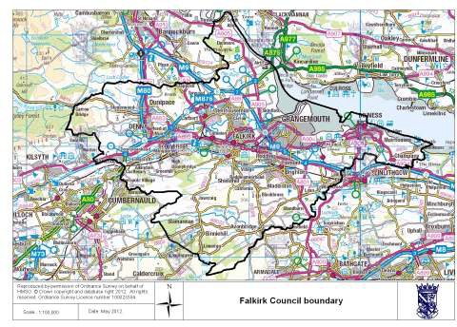

Figure 1.1: Falkirk Council Boundary

Applicable Air Quality Objectives
The air quality objectives applicable to Local Air Quality Management (LAQM) in Scotland are set out in the Air Quality (Scotland) Regulations 2000 (Scottish SI 2000 No 97), the Air Quality (Scotland) (Amendment) Regulations 2002 (Scottish SI 2002 No 297), and are shown in Table 1.1. This table shows the objectives in units of micrograms per cubic metre μg/m³ (and milligrams per cubic metre, mg/m³ for carbon monoxide) with the number of exceedances in each year that are permitted (where applicable).
Table 1.1:Air Quality Objectives included in the Regulations for the purposes of LAQM in Scotland
Pollutant | Air Quality Objective |  | Date to be achieved by
Pollutant | Concentration | Measured as | Date to be achieved by
Benzene | 16.25 Ig/m³ | Running annual mean | 31.12.2003
Benzene | 3.25 Ig/m³ | Running annual mean | 31.12.2010
1,3-Butadiene | 2.25 Ig/m³ | Running annual mean | 31.12.2003
Carbon monoxide | 10.0 mg/m³ | Running 8-hour mean | 31.12.2003
Lead | 0.5 Ig/m³ | Annual mean | 31.12.2004
Lead | 0.25 Ig/m³ | Annual mean | 31.12.2008
Nitrogen dioxide (NO₂) | 200 Ig/m³ not to be exceeded more than 18 times a year | 1-hour mean | 31.12.2005

Pollutant | Air Quality Objective |  | Date to be achieved by
Pollutant | Concentration | Measured as | Date to be achieved by
Pollutant | 40 Ig/m³ | Annual mean | 31.12.2005
Particulate Matter (PM₁₀) (gravimetric) | 50 Ig/m³, not to be exceeded more than 7 times a year | 24-hour mean | 31.12.2010
Particulate Matter (PM₁₀) (gravimetric) | 18 Ig/m³ | Annual mean | 31.12.2010
Sulphur dioxide (SO₂) | 350 Ig/m³, not to be exceeded more than  24 times a year | 1-hour mean | 31.12.2004
Sulphur dioxide (SO₂) | 125 Ig/m³, not to be exceeded more than 3 times a year | 24-hour mean | 31.12.2004
Sulphur dioxide (SO₂) | 266 Ig/m³, not to be exceeded more than 35 times a year | 15-minute mean | 31.12.2005

Local Air Quality Management
This report fulfils the requirements of the Local Air Quality Management process as set out in Part IV of the Environment Act (1995), the Air Quality Strategy for England, Scotland, Wales and Northern Ireland 2007 and the relevant Policy and Technical Guidance documents. The LAQM process places an obligation on all local authorities to regularly review and assess air quality in their areas, and to determine whether or not the air quality objectives are likely to be achieved.
Where a breach of the objective is identified by either monitoring or modelling, a local authority must declare an Air Quality Management Area (AQMA) and prepare an Air Quality Action Plan (this document) setting out the measures it intends to put in place in pursuit of the objectives. Local authorities are required to work towards achieving the objectives; however are not statutorily required to meet them.
As a result of this process Falkirk Council has declared the following AQMAs:
    - An AQMA in Grangemouth, for the 15-minute sulphur dioxide (SO₂) objective;
    - Initially two AQMAs in Falkirk Town Centre, one covering the hourly nitrogen dioxide (NO₂) objective another covering the annual mean NO₂ objective;
    - An AQMA in Haggs, for the annual mean NO₂ objective; and
    - An AQMA in Banknock, for a breach of the Scottish PM₁₀ and a potential breach of the UK PM₁₀ objectives.
It should be noted that the AQMA for the hourly NO₂ objective in Falkirk Town Centre was declared as a precautionary measure following preliminary modelling. Subsequent detailed monitoring and modelling conducted since the declaration has shown that this objective is being met and therefore this AQMA was revoked in January 2013. In addition, the annual AQMA for NO₂ has been varied to include the Scottish PM₁₀ objectives.
An Air Quality Action Plan has been prepared and in active use for the Grangemouth AQMA. A Further Assessment and Action Plan will be prepared for the Banknock AQMA. This document considers both the Falkirk Town Centre and Haggs AQMAs.

Figure 1.2 and Figure 1.3 show the Falkirk Town Centre and Haggs AQMAs respectively. This Action Plan relates to the Falkirk Town Centre and Haggs AQMAs. The primary emission source in each AQMA is road traffic, in contrast to the Grangemouth AQMA where industrial emissions are the predominant source.
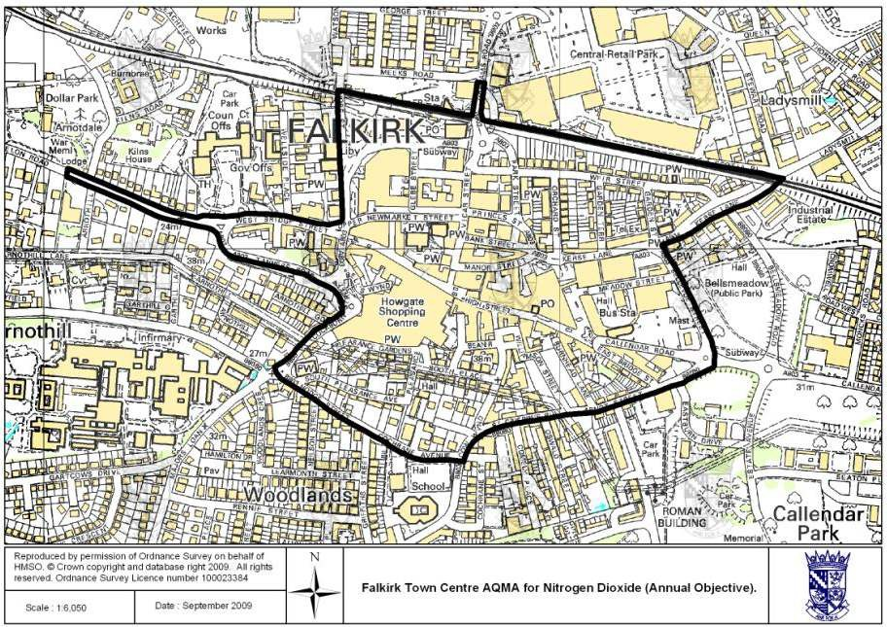
Figure 1.2: The boundary of the Falkirk Town Centre AQMA (annual mean NO2 objective and PM10 objectives)

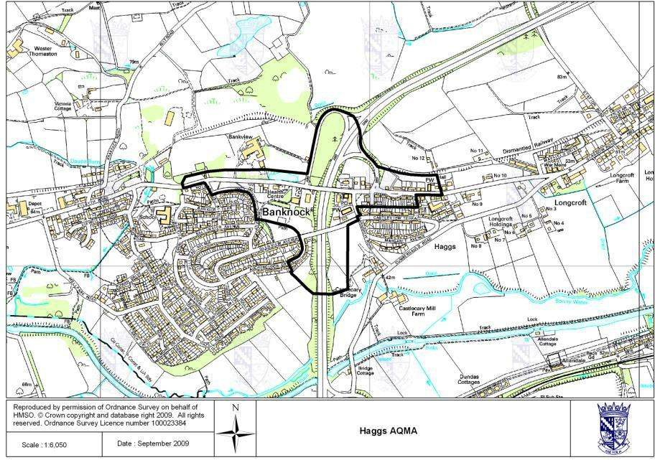
Figure 1.3: The boundary of the Haggs AQMA (annual mean NO2 objective)

It is important to note that the method of assessment that the UK and Scottish Governments are required to use to assess air quality in relation to their submissions to the European Union are not the same as LAQM. In addition, not all the objectives stated in Table 1.1 originate from the EU. This means that although there may be an AQMA in place this does not automatically translate to a breach of any objectives under EU legislation.

HEALTH IMPACTS OF ATMOSPHERIC POLLUTION
The adverse effects on human health caused by atmospheric pollution were first recognised in the UK in 1952, following a pollution episode in London which caused 4,000 deaths. In recognition of the significance of atmospheric pollution upon human health, national and international guidelines and emission limits were derived to protect the public from atmospheric pollution. The derived standards and emission limits have been set based on scientific and medical evidence on the effects of the pollutant on health. The extensive regulations for industry and other sources of atmospheric emissions have greatly improved the quality of air throughout the UK. Despite these improvements it is estimated that poor air quality reduces the life expectancy of each person in the UK by 7 to 8 months¹.

¹Defra et al, (2007).The Air Quality strategy for England, Scotland, Wales and Northern Ireland, Volume 1.

The health effects of atmospheric pollution can vary significantly in terms of severity and number of people suffering effects. Generally, the less severe effects occur in a greater majority of people and the more severe effects occur in a minority of people. Air pollution can also have both short and long term effects on health and the effect varies depending on the length of exposure, the pollutant concentration exposed to and on the sensitivity of the person being exposed. The people most likely to be affected by exposure to air pollution include young children and people with pre-existing lung, heart or respiratory disease.
This document focuses on the AQMAs declared for nitrogen dioxide and particulate matter that are predominately due to road traffic emissions. The remainder of this chapter therefore details the nature and origin of this atmospheric pollutant that can affect human health and a summary of air pollution and health.

Atmospheric Pollution
Air is a complex mixture which contains a range of substances considered to be pollutants, many of which have potentially harmful effects on health. The components of air that have most significance for health include particulate matter (PM), oxides of nitrogen (NO_{X}), sulphur dioxide (SO₂) and ozone (O₃). Local authorities are not required to review and assess for ozone as it is a transboundary pollutant which is created at distance from its precursor compounds (volatile organic compounds and NO_{X}), but is included here for completeness. Particulate matter and oxides of nitrogen have similar sources and frequently occur together. These compounds are considered in greater detail below.

Particulate Matter (PM)
Particulate matter consists of a mixture of particles of different sizes suspended in the air and is abbreviated to the letters PM with a subscript to indicate the aerodynamic diameter of the particles. For example, PM₁₀ represents the proportion of particulate matter less than 10Im in aerodynamic diameter. The aerodynamic diameter of particles governs several important features, including their patterns of deposition in the respiratory system, their chemical nature and their sources. Fine Particles are composed of a wide range of materials arising from a variety of sources including:
      - Combustion sources (mainly road traffic);
      - Secondary particles, mainly sulphate and nitrate formed by chemical reactions in the atmosphere, and often transported from far across Europe; and
      - Coarse particles, suspended soils and dusts (e.g. from the Sahara), sea salt, biological particles and particles from construction work.
Particles are measured in a number of different size fractions according to their mean aerodynamic diameter. Most monitoring is currently focused on PM₁₀, but the finer fractions such as PM_{2.5}is becoming of increasing interest in terms of health effects. Fine particles can be carried deep into the lungs where they can cause inflammation and a worsening of the condition of people with heart and lung diseases. In addition, they may carry surface-absorbed carcinogenic compounds into the lungs.

Oxides of Nitrogen (NO_{X})
Nitrogen forms several oxides including the compounds nitrogen dioxide (NO₂) and nitric oxide (NO). NO₂ in external air is mainly a secondary pollutant, formed by oxidation of NO, the primary source of which, in external air, is combustion of fossil fuels in motor vehicles.
Nitric oxide (NO) is mainly derived from road transport emissions and other combustion processes such as the electricity supply industry. NO is not considered to be harmful to health. However, once released to the atmosphere, NO is usually very rapidly oxidised to nitrogen dioxide (NO₂), for which objectives have been set by the Scottish Government. Nitrogen dioxide can irritate the lungs and lower resistance to respiratory infections such as influenza.NO₂ and NO are both oxides of nitrogen and together are referred to as nitrogen oxides (NO_{X}).

Sulphur Dioxide (SO₂)
Sulphur dioxide (SO₂) is produced when a material, or fuel, containing sulphur is burned. Globally, much of the sulphur dioxide in the atmosphere comes from natural sources, but in the UK the predominant sources are power stations burning fossil fuels, principally coal and heavy oils. Widespread domestic use of coal can also lead to high local concentrations of SO₂.
Elevated concentrations may result in a fall in lung function in asthmatics. Tightness in the chest and coughing occur at high levels, and lung function of asthmatics may be impaired to the extent that medical help is required. Sulphur dioxide pollution is considered more harmful when particulate and other pollution concentrations are high (Note though that the LAQM and other reporting processes do not take any possible ‘synergistic’ effects into account).

Ozone (O₃)
Ozone (O₃) is not emitted directly from any man-made source in any significant quantities. In the lower atmosphere, O₃ is primarily formed by a complicated series of chemical reactions initiated by sunlight. These reactions can be summarised as the sunlight-initiated oxidation of volatile organic compounds (VOCs) in the presence of nitrogen oxides (NO_{X}). The sources of VOCs are similar to those described for NO_{X} above, but also include other activities such as solvent use, and petrol distribution and handling.
The chemical reactions do not take place instantaneously, but can take hours or days, therefore ozone measured at a particular location may have arisen from VOC and NO_{X} emissions many hundreds or even thousands of miles away. Maximum concentrations, therefore, generally occur downwind of the source areas of the precursor pollutant emissions. Ozone irritates the airways of the lungs, increasing the symptoms of those suffering from asthma and lung diseases.

Summary of Health Effects of pollutants in the Air
- Air pollution is an important environmental risk factor for a range of cardiac and respiratory diseases. Although the risk associated with the exposure may be relatively small for the individual, the exposure
may be important at the population wide level;
- Particulate matter is one of most important components of contaminated air. Most of the evidence for the effects of polluted air on health concerns particulate matter;
- The effects of particulate matter are usually expressed in terms of PM₁₀ concentration. This fraction includes the fine component of particulate matter (PM_{2.5}) which penetrates to the small airways and the
ultrafine component (PM_{0.1}) which penetrates to the gas-exchanging tissues of the lungs, or alveoli. These are the components of particulate matter most implicated in health effects of air pollution. Particulate matter is associated with well-defined short-term and long-term effects on health;
- There is evidence for short-term increases in cardiovascular, respiratory and total hospital admissions at a lag of a few days following increases in the concentration of particulate matter; and
- There is also evidence for longer-term risks several years after exposure to polluted air. There is an increased risk of mortality for all cases of cardiopulmonary diseases and lung cancer.

Air Pollution Indexes
In the UK, most air pollution information services use the index and banding system recommended by the Committee on Medical Effects of Air Pollutants (COMEAP). The system uses an index numbered 1 to 10, divided into four bands to provide more detail about air pollution levels in a simple way, similar to the sun or pollen index. The index focuses on the short-term objectives (hourly and daily) and not the longer term (annual) objectives. The air quality index is shown in Table 2.1with further information, such as the levels used for each pollutant in each band, available at: http://uk-air.defra.gov.uk/air-pollution/daqi.

Table 2.1: The UK air quality index used on the UK-Air and Scottish Air Quality Network websites
Air Pollution Banding | Value | Accompanying health messages for at-risk groups and the general  population.
Air Pollution Banding | Value | At-risk individuals* | General population
Low | 1 - 3 | Enjoy your usual outdoor activities. | Enjoy your usual outdoor activities.
Moderate | 4 - 6 | Adults and children with lung problems, and adults with heart problems, who experience symptoms, should consider reducing strenuous physical activity,  particularly outdoors. | Enjoy your usual outdoor activities
High | 7 - 9 | Adults and children with lung problems, and adults with heart problems, should reduce strenuous physical exertion, particularly outdoors, and particularly if they experience symptoms. People with asthma may find they need to use their reliever inhaler more often.  Older people should also reduce physical exertion. | Anyone experiencing discomfort such as sore eyes, cough or sore throat should consider reducing activity, particularly outdoors.
Very High | 10 | Adults and children with lung | Reduce physical exertion, particularly outdoors, especially if you experience symptoms such as cough or sore throat.
Very High | 10 | problems, adults with heart  problems, and older people, should avoid strenuous physical activity. People with asthma may find they need to use their reliever inhaler more often.
* Adults and children with heart or lung problems are at greater risk of symptoms.

The UK Government’s requirements for providing air quality alerts are based on the following thresholds and requirements as set by European Union Directive 2008/50/EC and are:
- Ozone information: 180 Ig/m³ for one hour;
- Ozone alert: 240 Ig/m³ for one hour;
- Sulphur dioxide alert: 500 Ig/m³ for three consecutive hours over 100 km² area; and
- Nitrogen dioxide alert: 400 Ig/m³ for three consecutive hours over 100 km² area.

AIR QUALITY IN FALKIRK

Background Pollutant Concentrations
The background concentration is the residual pollutant concentration in an area that occurs without the contribution of local emission sources. The background concentration is akin to what would be experienced in a rural area. The background concentration encompasses two elements, contribution from transboundary emission sources and natural sources.
In addition to the background concentration, there is a contribution to ambient pollutant concentrations from diffuse sources, such as commercial and domestic combustion or general industrial activities. Whilst emissions from such sources will have a localised impact, the emissions tend to have a low level impact across a wider area. These diffuse, or area, emission sources contribute toward the ambient pollutant concentration, and as such this contribution is often included when referring to the background concentration.
The 2010 DEFRA LAQM² background maps for both NO₂ and PM₁₀ have been plotted and are presented in Figure 3.1 and Figure 3.3 respectively. The 2012 background data for NO₂ and PM₁₀, based on forward projected 2008 data, have also been plotted and are presented in Figure 3.2and Figure 3.4 respectively.

NO₂
The 2010 background concentration map (Figure 3.1) indicates that the highest background NO₂ concentrations are estimated in the M9 and M80 corridors and around the Grangemouth petrochemical complex. Estimated background concentrations range from less than 12 Ig/m³ in rural locations to >18Ig/m³ in ‘hotspot’ locations. As a maximum the estimated 2010 background concentrations are approximately 50% of the annual mean air quality objective for NO₂.
No significant difference in background concentrations is estimated for 2012 (Figure 3.2). Historically, a decrease in ambient and background NO₂ concentrations was predicted due to expected reductions in road vehicle and industrial emissions. In reality, the reduction in road vehicle emissions has not been realised, hence historic projections have been revised to reflect a less pronounced reduction in concentrations.

PM₁₀
The 2010 background map of PM₁₀ concentrations (Figure 3.3) indicates that the prevailing background concentration across the main urban parts of the Falkirk Council area is between 12 and 15 μg/m³. This represents between 67 to 83 % of the annual mean air quality objective for PM₁₀.
Background concentrations of greater than 15 Ig/m³are estimated at a few hotpots location close to the motorway network or at locations of industrial activity.
The 2012 background map (Figure 3.4) indicates that little reduction in background concentrations was predicted between 2010 and 2012.

²http://laqm.defra.gov.uk/review0and0assessment/tools/background0maps.html

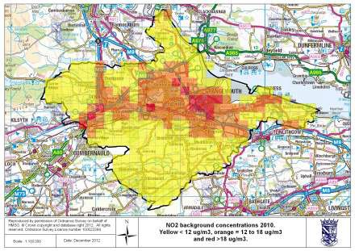
Figure 3.1: Background NO2 2010
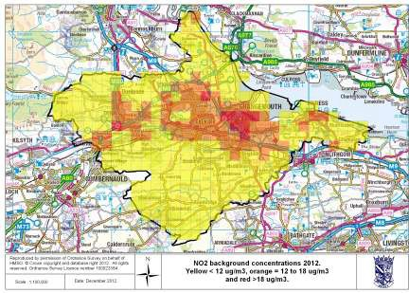
Figure 3.2: Background NO2 2012

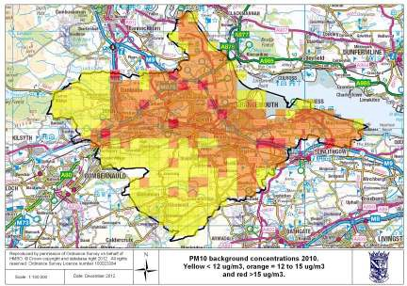
Figure 3.3: Background PM10 2010
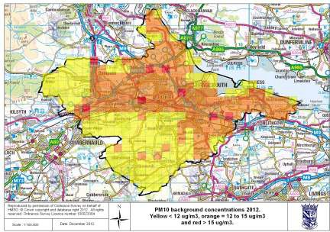
Figure 3.4: Background PM10 2012

Monitored Concentrations
The Council has continued to monitor both PM₁₀ and NO₂ concentrations in both the Falkirk Town Centre and Haggs AQMAs since the declarations in 2010, in order to determine compliance with air quality objectives.
The air quality objectives apply at areas of relevant public exposure as defined in LAQM Technical Guidance. Long term objectives, such as the annual mean objectives, should be applied at all locations where members of the public might be regularly exposed, for example, residential properties and institutional buildings. Relevant public exposure for short term objectives includes all locations for which the annual mean objectives are relevant as well as all other outdoor locations where the public might reasonably be expected to spend the applicable exposure period for the objective.

NO₂

Falkirk Town Centre AQMA
The Council currently monitors NO₂ levels using both passive diffusion tubes and automatic analysers. In the AQMA, NO₂ monitoring is carried out using a total of sixteen diffusion tube monitoring sites as well as automatic monitoring sites. There are three NO₂ automatic analysers located within the Falkirk Town Centre AQMA at Hope Street, Park Street and West Bridge Street. Full details of all automatic and non-automatic monitoring sites are provided in the 2012 Updating and Screening Assessment (USA) report and 2013 and 2014 Annual Progress Reports, however measured annual mean concentrations from each of the automatic analysers within the AQMA are presented in Table 3.1.

Table 3.1: Measured NO₂ annual mean concentrations in Falkirk Town Centre AQMA
Site ID | Monitor | Location | Annual mean concentrations (μg/m³)
Site ID | Monitor | Location | 2010 | 2011 | 2012 | 2013
A5. Falkirk Hope St | Automatic Monitor | Hope St, Falkirk | 27.7 | 24.1 | 25.1 | 23.0
A6. Falkirk Park St | Automatic Monitor | Park St, Falkirk | 32.9 | 28.5 | 33.2 | 30.4
A7. Falkirk West Bridge St | Automatic Monitor | West Bridge St, Falkirk | 43.8* | 35.9* | 43.4# | 39.2*
*Less than 90% data capture, therefore data has been annualised in accordance with methods in TG(09)
# Whilst data capture was less than 90% it was not possible to annualise as data loss was sporadic throughout year

The results indicate a general reduction in measured concentrations between 2010 and 2013. Exceedence of the annual mean objective for NO₂ has only been measured at the West Bridge Street monitoring site. In 2013, measured concentrations at all three sites were in compliance with the objective.
Measured NO₂ concentrations at diffusion tube monitoring sites within the Falkirk Town Centre AQMA are displayed graphically in Figure 3.5 and Figure 3.6.
The results indicate that since 2009 the overall trend in measured concentrations is generally stable with some increases observed at roadside sites. Particular peaks in concentrations were experienced in 2010 and at some sites in 2011. The results also indicate, however, that whilst annual mean concentrations are elevated across most of the town centre, the annual mean objective is being met at most monitoring sites. Measured exceedances of objectives are specific to the principal traffic routes.

Haggs AQMA
In the Haggs AQMA NO₂ monitoring is carried out using both diffusion tube monitoring sites and an automatic monitoring site. Full details of all automatic and non-automatic monitoring sites are provided in both the 2012 Updating and Screening Assessment and 2013 and 2014 Annual Progress Reports.
Measured NO₂ concentrations within the Haggs AQMA are displayed graphically in Figure 3.7. The results indicate no distinct trend between the monitoring sites. Measured concentrations in excess of the annual mean air quality objective are measured at Kerr Crescent diffusion tube only, with a modest decrease in concentrations observed since the AQMA was declared. As discussed in the 2012 USA the automatic monitor recorded a decrease of 7.6 Ig/m³ between 2011 and 2010. There are two potential reasons that the decline at this site is greater compared to other monitoring sites. The road works that were occurring in the vicinity of the analyser, for the A80 upgrade, ceased with the motorway fully opening in August 2011. This may have reduced congestion in the area. In addition, the Cowdenhill Quarry ceased operation in July 2011. This resulted in a reduction in lorry movements passing the monitoring site.











50
45
40
35
30
25
20
15
10
5
0
2006
2007
2008
2009
2010
2011
Kerse Arnot St, Camelon Bellevue Kerse
Lane, Falkirk. Rd, Falkirk. St, Falkirk. Lane, Falkirk Falkirk.
Park St AQ
station, Falkirk.
Park St, Vicar St,
Falkirk. Falkirk.
Hope St
AQ
station.
Grahams Grahams
Rd bridge Rd bridge
2012
2013
east,
Falkirk.
west,
Falkirk.
Cochrane
Avenue, Falkirk.
NA24
NA62
NA63
NA68
NA69
NA70
NA71
NA72
NA74
NA90
NA91
NA92

Figure 3.5: Falkirk AQMA Annual Mean NO2:g/m³ at Roadside Locations





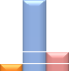

70
60
50
2006
40

30

20
2007
2008
2009
2010
2011
2012
2013
10
0
Weir St, Falkirk.
West Bridge St, Falkirk.
Upper Newmarket St, Falkirk.
West Bridge St RHS, Falkirk.
NA26
NA27
NA50
NA73

Figure 3.6: Falkirk AQMA Annual Mean NO2ug/m³







60
50
40
2006
2007
30
2008
2009
2010
2011
20
2012
2013
10
0
Kilsyth Rd, Banknock.
Kerr Crescent, Haggs.
Auchinloch Drive, Banknock
M80 slip south, Haggs
NA19
NA36
NA85
NA87

Figure 3.7: Haggs AQMA Annual Mean NO2:g/m³

PM₁₀
The Council currently monitors PM₁₀ levels using automatic analysers. There are three PM₁₀ automatic analysers located within the Falkirk Town Centre AQMA at Hope Street, Park Street and West Bridge Street. An automatic PM₁₀ monitor commenced operation at the Grahams Road site in December 2011 and at the Haggs site in December 2012.
The measured annual mean PM₁₀ concentrations at each monitoring location for 2008 to 2013 are presented in Table 3.2 and graphically in Figure 3.8.
The trend graph indicates that measured concentrations are generally stable. The most obvious trend is observed at West Bridge Street, where an overall decrease in PM₁₀ concentrations has been observed since 2008. Exceedance of the PM₁₀ annual mean objective has been measured at one site only, namely West Bridge Street, the analyser which is located to measure worst case exposure.

Table 3.2: Comparison with Annual Mean PM₁₀ Objective
Site ID | Monitor | Location | Annual mean concentrations (μg/m³)
Site ID | Monitor | Location | 2008 | 2009 | 2010 | 2011 | 2012 | 2013
A5. Falkirk Hope St | Automatic Monitor | Hope St, Falkirk | 15.3 | 15 | 15 | 15.2 | - | -
A6. Falkirk Park St | Automatic Monitor | Park St, Falkirk | 16.2 | 15 | 17 | 15.6 | 14.6 | 15.2
A7. Falkirk West Bridge St | Automatic Monitor | West Bridge St, Falkirk | n/a | 22.3 | 21 | 18.7 | 17.8 | 19.5
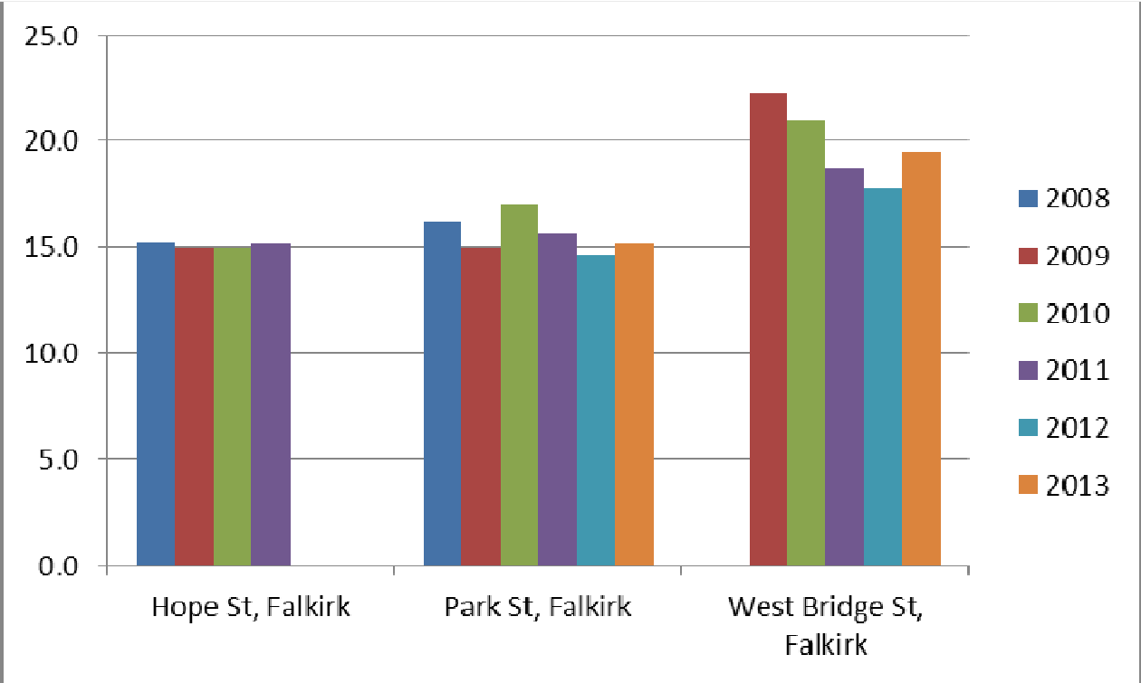
Figure 3.8: Trend graph of annual mean PM10:g/m³

Emissions Inventory
In order to provide information on what elements make up the background contribution to NO_{X} and PM₁₀ levels in the region, an emissions inventory for the Falkirk Council area was compiled using the atmospheric emissions database package EMIT³, which aggregates emissions into 1 km by 1 km grid squares. This was undertaken as part of the Falkirk Town Centre LAQM Further Assessment Study and the Haggs LAQM Further Assessment. The inventory includes emissions from the following sources:
- Road traffic;
- Commercial and domestic combustion – including stationary combustion sources in agriculture, domestic combustion, small scale industrial combustion, commercial combustion and public sector
combustion;
- Industrial combustion – including medium scale industry emissions e.g. combustion manufacturing or production facilities;
- Industrial processes – including non-combustion process emissions;
- Large industrial sources – including medium scale industry emissions;
- Other transport, i.e. air rail and marine transport;
- Waste treatment and disposal – sources included in this group are crematoria, incineration of animal carcasses, chemical waste and clinical waste and small-scale waste burning;
- Solvent use – emission data from solvent use associated with paints, glues, detergents and industrial processes;
- Agriculture – emission data from all agricultural livestock, poultry and agricultural off road machinery; and
- Nature – emission data from naturally occurring emissions from woodlands, mines, quarries and opencast mines.
Road traffic data were obtained from Falkirk Council and Transport Scotland, while data from all other sources were obtained from the National Atmospheric Emissions Inventory (NAEI). The NAEI has been compiled on behalf of DEFRA and the devolved administrations. The NAEI estimates emissions from different emission sources based on national emissions factors and estimates of activity for each emission source, e.g. quantity and type of fuel combusted and the emissions are aggregated into square kilometre areas.
The NAEI covers all areas of the UK, including the Falkirk Council area. Using the emissions estimates within the NAEI high level dispersion modelling studies have been undertaken to estimate background pollutant concentrations on a square kilometre basis. The predicted background concentrations are verified against local monitoring data to provide an estimate of the prevailing background concentration in each kilometre grid square. The estimates of background pollutant concentrations are undertaken periodically, with the most recent estimates of background pollutant concentrations based on 2007 data. The study assumed that 2007 emissions from the NAEI remain unchanged in 2008, 2009 and 2010.

³ EMIT Atmospheric Emissions Inventory Toolkit, version 2.2, Cambridge Environment Research Consultants, February 2006

Falkirk Town Centre AQMA NAEI Emissions Totals
The total NO₂ and PM₁₀ atmospheric emissions from the 1 km grid squares covering the Falkirk AQMA from the Further Assessment are presented in Table 3.3with the totals broken down by source in Figure 3.9andFigure 3.10.

Table 3.3: Emissions inventory totals at Falkirk Town Centre AQMA
Source | NOX Emitted (tonnes/year) | PM10 Emitted (tonnes/year)
Agriculture | 0.0 | 0.0
Commercial, Institutional and Residential Combust | 26.0 | 1.6
Energy Production | 0.0 | 0.0
Rail | 17.6 | 0.5
Industrial Combustion | 1.8 | 0.0
Industrial Processes | 0.0 | 0.9
Nature | 0.1 | 0.3
Solvent use | 0.0 | 0.2
Waste Treatment | 0.0 | 0.7
Road transport | 48.7 | 2.5
Total | 94.1 | 6.7

The results indicate that road traffic sources are the highest contributor of NO_{X} emissions, with commercial/residential combustion, industrial combustion and rail traffic emissions accounting for the remainder. Figure 3.7 indicates that the principal source of PM₁₀ in Falkirk is also road traffic, with commercial/residential combustion a significant contributor.






Agriculture
27%
Commercial, Institutional and Residential
Combust
Energy Production Rail
Industrial Combustion
52%
Industrial Processes
Nature Solvent use
19%
Waste Treatment
2%
Road transport
Figure 3.9: Falkirk AQMA NOX emission sources





0%
Commercial, Institutional and Residential
Combust
24%
Rail
38%
Industrial Combustion

Industrial Processes
8%
Nature
0%
Solvent use
13%
10%
Waste Treatment
3% 4%
Road transport
Figure 3.10: Falkirk AQMA: PM10 emission sources

Haggs AQMA NAEI Emissions Totals
The total NO₂atmospheric emissions from the 1 km grid squares covering the Haggs AQMA from the Further Assessment are presented in Table 3.4 with the totals broken down by source in Figure 3.11. The results indicate that the principal contributor to NO_{X} emissions is road transport with commercial/residential combustion, industrial combustion and other transport accounting for the remainder.

Table 3.4: Emissions inventory totals at Haggs AQMA
Source | NOX Emitted (tonnes/year)
Agriculture | 0
Commercial, Institutional and Residential Combustion | 6.1
Energy Production | 0.0
Industrial Combustion | 0.8
Industrial Processes | 0.0
Nature | 0.0
Other Transport | 13.0
Road Transport | 124.6
Solvent use | 0.0
Waste Treatment | 0.0
Total | 144.5
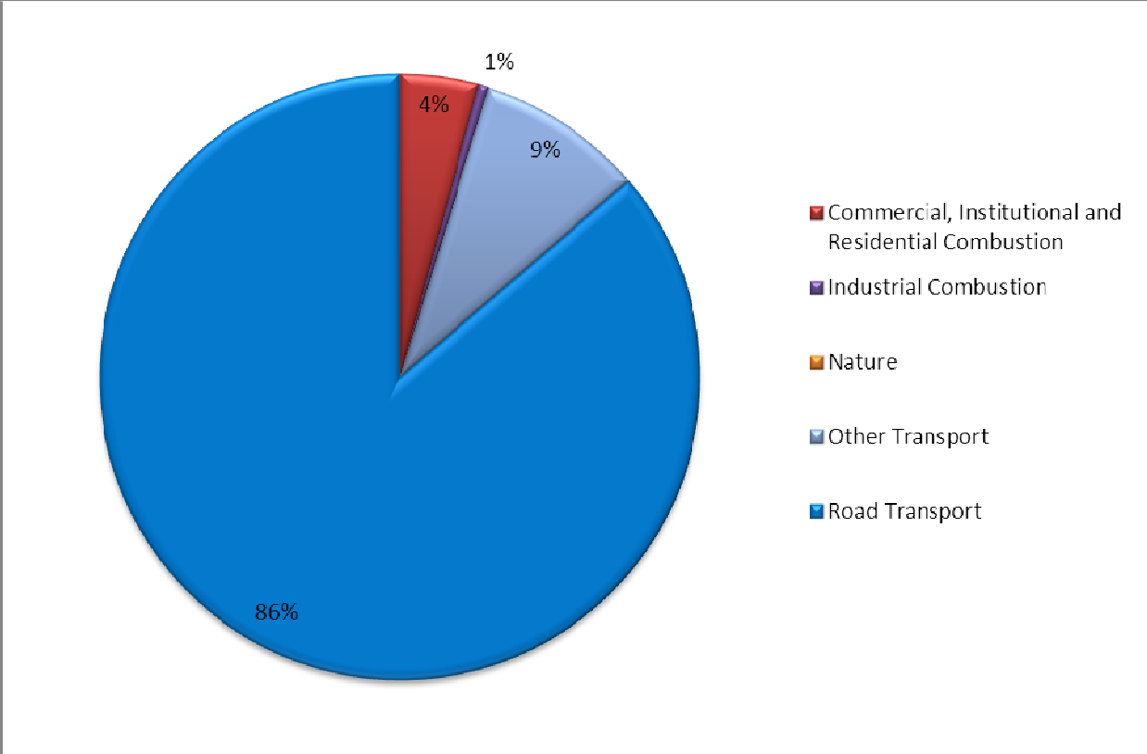
Figure 3.11: Haggs AQMA: NOX Emission Sources

Source Apportionment
A source apportionment study was undertaken as part of each Further Assessment of both AQMAs. Modelling was used to investigate which sources of PM₁₀ and NO_{X} had the highest contribution to predicted pollutant concentrations in the Falkirk Town Centre AQMA. Similarly modelling was used to identify the highest contribution of NO_{X} with the Haggs AQMA. The “Groups” feature of ADMS-Roads was used to include different sources and the model then predicted pollutant concentrations as a result of emissions from each group. The groups which were included were:
- All sources (road traffic emissions and volume sources);
- All road traffic emissions; and
- Volume sources (local background).
This allowed calculation of the fraction of the total predicted NO₂ annual mean attributable to the following sources:
- Regional background;
- Volume sources (i.e. local non-road traffic sources);
- Road sources only (with queuing traffic excluded); and
- Queuing traffic only.

Haggs
To demonstrate the contribution of each source to annual mean NO₂ concentrations at the receptors specified in the study, NO₂ concentrations attributable to each source in the Haggs AQMA are presented in Figure 3.12.
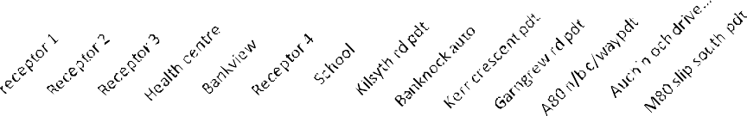
NO₂ Source apportionment
70

60

50
Congestion
40
Road sources
30
Local background
20
Regional
background
10

0
Figure 3.12: NO2 source apportionment at Haggs AQMA

The results indicate that a high proportion of the total NO₂ concentration, at each of the specified receptor locations, is attributable to road traffic emissions. The contribution of road traffic emissions can be further split between the contribution of traffic from the M80 and emissions from traffic on local roads (including the M80 slip roads). The relative contribution of emissions from the different traffic sources and all other sources are presented for NO_{X} and PM₁₀ in Figure 3.15 and Figure 3.16 respectively. It should be noted that the contributions are for total NO_{X} rather than NO₂, as the effects of secondary NO₂ formation mean that NO₂ concentrations cannot be directly attributed. The relative contributions therefore differ from that outlined in Figure 3.12.
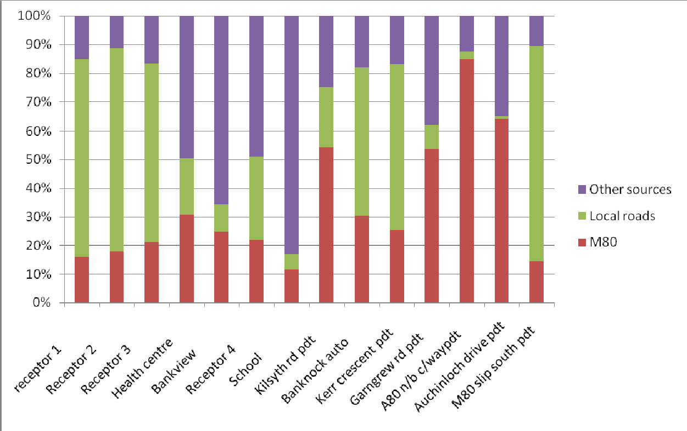
Figure 3.13: NOXSource Apportionment Haggs AQMA

The results indicate that the contribution of NO_{X} emissions from the M80 typically varies from 10-20% up to 60% at the receptors closest to the M80. Conversely, at receptors further from the M80 the contributions are reversed, with the contribution from local roads varying from 10-20% to 60%.
Analysis was undertaken of the contribution of differing vehicle types to overall emissions from road traffic. Two groups were considered: cars and light good vehicles; and buses and heavy goods vehicles. The contribution of different vehicle group types varies between the M80 and local roads, however in general, the following conclusions were noted:
- The contribution of cars and light goods vehicles to ambient NO₂ levels from vehicles on the M80 is typically 15-20% from cars and light goods vehicles, with the 80-85% majority attributable to buses and
heavy goods vehicles;
- In relation to local roads the contribution of different vehicle types was relatively even with approximately 45-50% from cars and light goods vehicles and 50-55% from buses and heavy goods
vehicles.

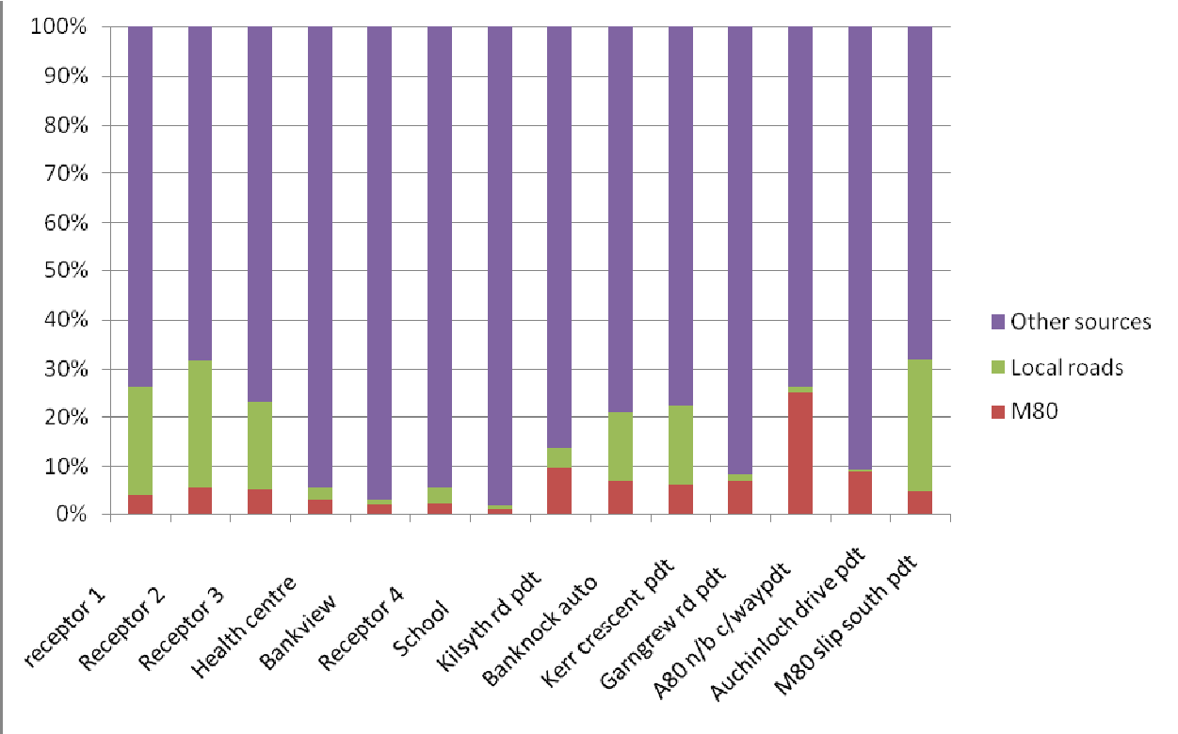
Figure 3.14: PM10Source Apportionment Haggs AQMA

The results indicate that the contribution of PM₁₀ emissions from the M80 is typically less than 10% at all receptors. The variation in contribution from road traffic on local roads is more variable, ranging from less than 5% at receptors further from the main local roads to 25% at receptors closest to local roads.
The contribution of different vehicle group types to the overall contribution from each source varies between the M80 and local roads, however in general, the following conclusions were noted:
- The contribution of cars and light goods vehicles to ambient NO₂ levels from vehicles on the M80 is typically around 30% from cars and light goods vehicles, with the 70% majority attributable to buses and
heavy goods vehicles;
- In relation to local roads the contribution of from cars and light goods vehicles was around 70% and 30% from buses and heavy goods vehicles.
The effect of queuing or congested traffic is greatest at the receptor locations closest to the roundabout and is negligible at locations away from the modelled queues. Based on the results of the source apportionment study, a reduction of road traffic emissions by up to approximately 20% is required to enable compliance with the NO₂ air quality objectives at receptor locations.

Falkirk Town Centre
The relative contribution of each source to ambient NO₂ and PM₁₀ concentrations in the Falkirk Town Centre AQMA was calculated by dispersion modelling of each source. Due to the effect of secondary chemical reactions on ambient NO₂ concentrations, the apportionment analysis was undertaken for predicted total NO_{X} concentrations. The results of the source apportionment are presented in Figure 3.15 and Figure 3.16.
Both figures indicate that, at locations where the NO_{X} and PM₁₀ concentrations are predicted to exceed objective levels the exceedances are principally attributable to road traffic emissions, in some cases exacerbated by emissions from queuing traffic.

The effect of queuing or congested traffic is greatest at the receptor locations on West Bridge Street and is negligible at roads on which little queuing occurs. The source apportionment study demonstrates that targeting of road traffic related emissions is required to enable compliance with the PM₁₀ and NO₂ air quality objectives at all areas of relevant public exposure.
Analysis was undertaken of the contribution of differing vehicle types to overall emissions from road traffic. The level of detail on the traffic breakdown in the model for most roads was limited, therefore vehicles were classified into two groups:
- Cars and light good vehicles; and
- Buses and heavy goods vehicles.
The contribution of different vehicle group types varies by road receptor considered, however in general, the following conclusions were noted:
- The contribution of cars and light goods vehicles to ambient NO₂ levels is typically 35-40%, with the 60- 65% majority attributable to buses and heavy goods vehicles;
- The contribution of cars and light goods vehicles to ambient PM₁₀ levels is more variable, ranging from 41—57% across most roads in the town centre;
- The contribution of buses and HGV’s to ambient NO₂ and PM₁₀ concentrations is greater on stretches of Callendar Road and on Upper Newmarket Street (reflecting traffic restrictions on this road).
Overall, therefore it can be assumed that bus and HGV emissions are having a higher proportional effect on ambient air quality than the relative contributions to traffic flows.

250
200
150
Congestion
100
Normal traffic
Local Background Regional Background
50
0

Figure 3.15: NOXSource Apportionment Falkirk AQMA

35
30
25
20
Congestion
15
Normal traffic
Local Background Regional Background
10
AQ objective
5
0
Figure 3.16: PM10Source Apportionment Falkirk AQMA

POLICIES, PLANS AND DEVELOPMENTS LIKELY TO IMPACT ON THE COUNCILS AIR QUALITY ACTION PLAN
Falkirk Council has little or no influence over emissions from sources outside its boundary, therefore any measures adopted to reduce pollutant levels will also require to be based around influencing national or regional policies or plans. There are a number of related policies and strategies, at the local and regional level, that can be tied in directly with the aims of the Air Quality Action Plan. Some of these policies and strategies are focused on transportation issues, and therefore are likely to help contribute to overall improvements in air quality across the Council area. This section outlines policies, plans and other known factors that have the potential to impact on NO₂ and PM₁₀ concentrations in Falkirk.

Roads and Transportation Policies and Plans

National Transport Strategy
Scotland’s Transport Strategy follows on from the 2005 Transport White Paper, Scotland’s Transport Future. The National Transport Strategy aims to address the key challenges facing the Scottish transport system today. These are an increase in the number of vehicles on the roads, in particular passenger cars, coupled with a decrease in the use of public transport. The Scottish Government has identified a need for a more efficient, integrated and reliable transport network which can encourage economic growth, environmental protection and social inclusion while helping to reduce congestion, reduce journey times, reduce car use and improve public transport. To help achieve these aims, the National Transport Strategy outlines three main outcomes:
      - Improve journey times and connections, to tackle congestion and the lack of integration in transport;
      - Reduce emissions, to tackle the issues of climate change, air quality and health improvement; and
      - Improve quality, accessibility and affordability, to give people a choice of public transport, where availability means better quality services and value for money or an alternative to the car.

Regional Transport Strategy
Falkirk Council is located within the SEStran (the South East of Scotland Transport Partnership) area. The Scottish regional transport authorities were formally enacted as a result of the Transport (Scotland) Act 2005. Each Regional Transport Partnership has produced a Regional Transport Strategy which is supported by a delivery plan where regional transport partnerships set out when and how projects and proposals would be delivered.
It should be noted that unlike other regional transport authorities (Nexus, Transport for Greater Manchester, Strathclyde Passenger Transport etc.) SEStran does not have responsibility for procuring socially necessary services. This role remains with the Local Authorities. The situation is also different to London, where the regional transport authority, Transport for London, has again different (and more extensive powers) for transport provision.
The main objectives of the SEStran Regional Transport Strategy (2008 - 2023) are:
      - Economy: to ensure transport facilities encourage growth, regional prosperity and vitality in a sustainable manner;
      - Accessibility: to improve accessibility for those with limited transport choice or no access to a car; particularly those living in rural areas;
      - Environment: to ensure that development is achieved in an environmentally sustainable manner; and
      - Safety & Health: to promote a healthier and more active SEStran area population.
Air quality is covered by Objective 3 Environment - to ensure that development is achieved in an environmentally sustainable manner.

Specifically in:
  - “to contribute to the achievement of the UK’s national targets and obligations on greenhouse gas emissions” and
  - “to minimise the negative impacts of transport on natural and cultural resources.”
Policy 29: Transport interventions will be designed and operated to minimise their impact on the environment.
Policy 30: Interventions in the RTS should contribute to the achievement of national and international targets related to local air quality climate change particularly reducing emissions of CO₂ and other greenhouse gases.
Policy 37: there will be a presumption in favour of schemes that assist the achievement of local air quality targets.
Target 4.3 of the strategy states that it will “meet or better all statutory air quality requirements”.

Falkirk’s Local Transport Strategy
Air Quality is covered in the Local Transport Strategy by Objective 3 “To protect the environment by minimising the impact of transport can have on it and to improve health by promoting more active travel”. This will hopefully be achieved through various policies including those specific to air quality listed below.
AQ1: The Council will continue to monitor and analyse air quality data throughout the Council area in compliance with the requirements of the Environment Act 1995 and subsequent regulations.
AQ2: The Council will work with partner agencies, to implement transport initiatives to assist in improving air quality and to work towards achieving the air quality objectives through the measures that will (in due course) be outlined in the air quality Action Plans.

Planning and Development Policies and Plans
The first National Planning Framework (NPF1) for Scotland, published in 2004, set out a strategy for Scotland’s development to 2025. The preparation of this second National Planning Framework (NPF2) has provided an important vehicle for the national debate about the sort of place we want Scotland to be. It guides Scotland’s development to 2030, setting out strategic development priorities to support the Scottish Government’s central purpose: sustainable economic growth. The Planning etc. (Scotland) Act 2006 puts this and future iterations of the National Planning Framework on a statutory footing.
The Framework will play a key role in co-ordinating policies with a spatial dimension and aligning strategic investment priorities. It takes forward the spatial aspects of the Government Economic Strategy, highlighting the importance of place and identifying priorities for investment to enable each part of the country to play to its strengths. It provides the strategic spatial policy context for decisions and actions by the Government and its agencies. Planning authorities are required to take the Framework into account when preparing development plans and it is a material consideration in the determination of planning applications.
NPF2 is concerned with Scotland in its wider context and addresses the major contemporary challenges of global competition, climate change and resource depletion. It is informed by the European Union’s territorial agenda, its priorities for promoting economic competitiveness and protecting the environment and its targets for energy supply and the reduction of greenhouse gas emissions. It provides the starting point for collaboration in wider spatial planning initiatives.
NPF2 builds on the first National Planning Framework, drawing on the analysis contained in the 2006 Monitoring Report and the views of stakeholders. It identifies key issues and drivers of change, sets out a vision to 2030, and identifies priorities and opportunities for each part of the country in spatial perspectives for the Central Belt, the East Coast, the Highlands and Islands, Ayrshire and the South-West and the South of Scotland.

The NPF2 takes forward the spatial aspects of the Scottish Government’s policy commitments on sustainable economic growth and climate change, which will see Scotland move towards a low carbon economy. It focuses strongly on priorities for the improvement of infrastructure to support long-term development. For transport infrastructure, it promotes the strategic outcomes set out in the National Transport Strategy and incorporates the findings of the Strategic Transport Projects Review. It identifies strategic priorities for investment in energy and drainage infrastructure and emphasises the priority the Government attaches to the development of a strategic network of waste management installations.
The NPF can designate certain developments as national developments and the Town and Country Planning (Development Management Procedures) (Scotland) Regulations 2008 and Circular 4/2009: Development Management Procedures set out the process for the consideration of such developments. In a statement to Parliament in September 2007, the Cabinet Secretary for Finance and Sustainable Growth set out the criteria which Ministers would use in designating national developments. NPF2 identifies a number of major transport, energy and environmental infrastructure projects which Ministers consider to be essential elements of the strategy for Scotland’s long-term development on the basis of an assessment against these criteria. The national developments that are likely to be relevant to the Falkirk Council area and potentially its Air Quality Management Areas are the following:
- Grangemouth Freight Hub (Improvements in port, road and rail infrastructure to support the role of Grangemouth as Scotland’s largest container port and main freight distribution centre);
- Addition container freight capacity on the Forth (Multimodal container terminal facilities, including improvements in supporting port, road and rail infrastructure);
- New non-nuclear (electricity) base load capacity at other existing power station sites; and
- Central Scotland Green Network (A strategic network of woodland and other habitats, active travel routes, greenspace links, watercourses and waterways, providing an enhanced setting for development
and other land uses and improved opportunities for outdoor recreation and cultural activity).
The NPF2 is closely linked to the Government’s Infrastructure Investment Plan and informs the investment programmes of public agencies and infrastructure providers. It is supported by an action programme, identifying how, when and by which organisations key elements of the strategy will be taken forward. The Planning etc. (Scotland) Act 2006 requires the preparation of a Participation Statement and has also been considered by the Scottish Parliament.
The NPF2 has been subject to a Strategic Environmental Assessment (SEA).This process has included scoping, an interim assessment of the alternatives considered during strategy development, a fuller assessment of the discussion draft NPF and a supplementary assessment of candidate national developments.
There is a requirement to assess the policies may impact on different sectors of the population. NPF2 is the spatial expression of established policies which have been subject to Equality Impact Assessment as part of their development. The planning procedures which will apply to projects designated as national developments were subject to Equality Impact Assessment as part of the recent review of Planning Regulations.
The NPF2 document states that the Scottish Government is committed to improving air quality and is giving particular priority to addressing problems in designated Air Quality Management Areas (AQMAs). Where a proposed development could have significant impacts on air quality, close co-operation between planning authorities and those with responsibility for air quality and pollution control will be essential.
The Proposed National Planning Framework 3 (NPF3) is the spatial interpretation of the Government Economic Strategy. The Proposed NPF3 sets out our ambition for Scotland to become: a successful, sustainable place; a low carbon place; a natural, resilient place; and a connected place. Fourteen national developments are proposed to help deliver the strategy. This document was laid to the Scottish Parliament on the 14 January 2014.

Falkirk Local Development Plan
Falkirk Council is preparing a new Local Development Plan (LDP) for the area. It is anticipated that the plan will be adopted in June 2015. When adopted, it will replace the current Structure Plan and Local Plan with a single planning document which will guide development in the area for the period 2014-2034.
Development plans are prepared by local authorities to guide the use and development of land within their areas. They contain policies and proposals which indicate where development should, and should not take place, and which provide guidance on topics such as housing, business and industry, shopping, transport and infrastructure, recreation and community facilities and built and natural heritage.
Development plans highlight areas which should be protected from development, such as countryside, green belt, and nature conservation sites, and opportunities for the enhancement of the environment. They set out standards which new development should meet in terms of quality, design and how the development should contribute to social and physical infrastructure. Development plans are seen as a key mechanism for promoting sustainable development.
Development plans are statutory documents. The requirement to produce them, their broad content, and the process to be followed in preparing them are set out in legislation. They are particularly important because they are the main consideration in determining planning applications. The planning system is intended to be ‘plan-led’, with decisions on planning applications made in accordance with the development plan unless other material considerations indicate otherwise.
The LDP includes proposed measures which have implications for both the Falkirk and Haggs AQMAs. Land has been allocated around Haggs for residential development, adjacent to the current AQMA. The planning system will ensure, however that any development will be located at suitable distance from roads to ensure compliance with air quality objectives.
The LDP will include a specific policy related to air quality (Policy RW07), as follows:
“The Council will seek to contribute to the improvement of air quality. Impacts on air quality will be taken into account in assessing development proposals, particularly within Air Quality Management Areas (AQMAs). An Air Quality Assessment may be required for developments that are within AQMAs or where the proposed development may cause or significantly contribute towards a breach of National Air Quality Standards. Development proposals that result in either a breach of National Air Quality Standards or a significant increase in concentrations within an existing AQMA will not be permitted unless there are over0riding issues of national or local importance.”

Corporate Policies and Plans

Single Outcome Agreement
The Single Outcome Agreement for 2009 to 2011 contained the following outcome in relation to the air quality monitoring sites:
      - Compliance with EU, UK and Scottish Government air quality objectives at all 9 monitoring sites within the Council area.
Falkirk Council has therefore reported the compliance with this indicator. The indicator has been adjusted to take account of the changes in the number of monitoring stations and will continue to be reported.

Falkirk Council Strategic Community Plan 2010 - 2015
The Strategic Community Plan 2010 - 2015: Moving Forward Together sets out the things we need to do to ensure we meet our vision for our area.
To help achieve the vision of a sustainable Falkirk:
      - The quality of our infrastructure will help promote the growth of the local economy;
      - We will be greener;
      - We will improve the built environment; and
      - Our open spaces will be attractive, accessible and safe.
The plan acknowledges the balance to be sought between the potential in Grangemouth and the local environment and this can be equally to road traffic emissions as well:
“One of the tensions we face in the Falkirk Council area is promoting the opportunities associated with the petrochemicals sector at Grangemouth, continuing economic growth, while maintaining the quality of the local environment and reducing our carbon footprint.”
The plan also notes the changing methods in way that people travel:
“Over the last 20 years we have seen an unprecedented increase in the number of cars on our streets. This not only has an impact on the environment but potentially also impacts on our health, as we choose not to walk, even for short journeys. However, recently, we have seen an increase in the number of children walking to school, more people using the train to commute and an increase in the popularity of cycling. The area has developed a comprehensive paths network that opens up our towns, villages and countryside to more people than ever.”

Falkirk Council Corporate Plan
The goals of Falkirk Council’s Corporate Plan for 2012 to 2017 are:
      - Further developing a thriving sustainable and vibrant economy;
      - Continuing to improve the health, safety and wellbeing of our citizens and communities;
      - Increasing our efforts to tackle disadvantage and discrimination; and
      - Enhancing and sustaining an environment in which people want to live and visit.

Service Improvement Plan
The Development Services Service Improvement Plan for 2011 to 2014 states:
“Our citizens and communities will be encouraged to take responsibility for their own health and well-being. To ensure this we will: Prepare bids to extend the scheme (“Take the Right Route”) to other areas personalised travel planning Market and promote walking, cycling and public transport through initiatives such as personal travel plans.”
“Local Transport Strategy: Our profile will reflect our area as a destination of choice, to ensure this we will: Promote an efficient, sustainable, integrated, safe, multi-modal transport system that minimises environmental impact and promotes green travel initiatives. Implement the action plans for each transport mode; promote travel plans with local employers; enhance the accessibility of communities by providing footways, cycle ways and other means and promote walking and cycling.”
“Indicators, number 20: The percentage of children travelling actively to school (walking, cycling or skating).”

The service plan also includes performance indicators in relation to traffic light failures to maximise traffic flow. Traffic light failures will be completed within 48 hours (96.8% compliance rate in 2013/14).

Sustainable Development / Climate Change Policies and Plans

Climate Change (Scotland) Act 2009
The Climate Change (Scotland) Act 2009 (called ‘the Act’ in this section) received Royal Assent on
4 August 2009. The Scottish Government considers this to be the most far-reaching environmental legislation enacted by the Parliament during the first ten years of devolution. In addition, the Scottish Government thinks that reducing greenhouse gas emissions and transitioning to a low carbon economy will help create a more successful country, with opportunities for all of Scotland to flourish, through increasing sustainable economic growth.
Part 1 of the Act, creates the statutory framework for greenhouse gas emissions reductions in Scotland by setting an interim 42 per cent reduction target for 2020, with the power for this to be varied based on expert advice, and an 80 per cent reduction target for 2050. To help ensure the delivery of these targets, this part of the Act also requires that the Scottish Ministers set annual targets, in secondary legislation, for Scottish emissions from 2010 to 2050.As an example of this The Climate Change (Annual Targets) (Scotland) Order 2011, section 2, states:
“The annual targets expressed in tonnes of carbon dioxide equivalent(d) for the period 2023-2027 are as follows:
- The annual target for 2023 is 37,161,000;
- The annual target for 2024 is 35,787,000;
- The annual target for 2025 is 34,117,000; and
- The annual target for 2026 is 32,446,000.”
The Scottish Ministers will take advice on the targets they set. In the first instance this advice will be provided by the UK Committee on Climate Change. However, Part 2 of the Act contains provisions which will allow the Scottish Ministers to establish a Scottish Committee on Climate Change or to designate an existing body to exercise advisory functions should it be decided that this is appropriate.
Part 3 places duties on the Scottish Ministers requiring that they report regularly to the Scottish Parliament on Scotland's emissions and on the progress being made towards meeting the emissions reduction targets set in the Act. Part 4 places climate change duties on Scottish public bodies. This Part also contains powers to enable the Scottish Ministers, by order, to impose further duties on public bodies in relation to climate change.
The Act includes other provisions on climate change in Part 5, including adaptation, forestry, energy efficiency and waste reduction. Public engagement is a significant feature of Part 6 of the Act, which also includes provision on carbon assessment.

Falkirk Council Carbon Management Plan
In August 2011 Falkirk Council approved a carbon management plan to reduce emissions from its estate and activities. The measures in the plan are split into three categories:
- Officer led action;
- Service led action; and
- Cultural change to embed carbon management.

The back bone of the plan is a series of 43 projects to reduce carbon dioxide emissions with a total capital cost of £2.73 million. In addition, the plan suggests a new post of Climate Change Officer to be set up within Falkirk Council to manage the delivery of the plan.

Ref | Project | Project  Status | Air  Quality? | AQ Comments
1 | Upgrade to condensing boilers could apply to 45% of our offices | Started | Green
2 | Pipe work insulation could apply to 4% of our offices | Started | Green
3 | Automatic lighting controls could apply to 24% of our offices | Started | Green
4 | Localised lighting could apply to 2.5% of our offices | --- | Green
5 | Voltage optimisation could apply to 5% of our offices | --- | Green
6 | Awareness raising campaign could apply to 100% of our offices | --- | Green
7 | PC switch off could apply to 90% of our PCs | Started | Green
8 | Extend district heating to Callendar Park could apply to 4% of our offices | Complete | Green | More efficient use of existing resource.
9 | SMART meters could apply to 24% of our offices | Started | Green
10 | Rationalise use of offices- could apply to 100% of our offices | --- | Green | Applicable to energy and transport  consumption.
11 | Loft insulation could apply to 48% of our schools | --- | Green
12 | Building Management Systems could apply to 10% of our schools | Complete | Green
13 | Upgrade to condensing boilers - could apply to 45% of our schools | Started | Green
14 | Fuel switching to bio-fuel could apply to 2.2% of our schools | --- | Red | Change from oil to biomass. Unlikely  due to long payback period.
15 | Voltage optimisation could apply to 10% of our schools | --- | Green
16 | Awareness raising campaign could apply to 100% of our schools | --- | Green
17 | SMART meters could apply to 60% of our schools | Started | Green
18 | Heat from Callendar Flats combined heat & power scheme could be extended to Graeme HS - could apply to 10% of our schools | --- | Green
19 | PC Switch Off could apply to 100% of our school PCs | --- | Green
20 | Rationalise use of primary schools could apply to 60% of our  schools | --- | Green
21 | Upgrade to condensing boilers could apply to 45% of our leisure  facilities | --- | Green
22 | Automatic lighting controls could apply to 24% of our leisure  facilities | Started | Green
23 | Localised lighting could apply to 2.5% of our leisure facilities | --- | Green
24 | Grangemouth Stadium replace lighting | Complete | Green
25 | Variable speed drives could apply to 33% of our leisure facilities | Complete | Green
26 | Pool covers - Mariner Centre | --- | Green
27 | Voltage optimisation could apply to 18% of our leisure facilities | --- | Green
28 | Awareness raising campaign could apply to 100% of our leisure  facilities | --- | Green
29 | Rationalise use of sites - could apply to 100% of our leisure  facilities | --- | Green
30 | Streetlight dimming could apply to 18.5% of our streetlights | --- | Green
31 | LED could apply to 0.9% of our streetlights | --- | Green
32 | Replace 80W MBF with 55 W PLL could apply to 3.3% of our  streetlights | --- | Green
33 | Staff driver training & maintenance could apply to 95% of our  transport | --- | Green
34 | Low carbon replacement vehicles could apply to 22% of our  transport | Started | Green | Green as electric / hybrid vehicles.
35 | Kinneil fuel bunker could apply to 2.2% of our transport | Complete | Green | Reduced distance to re-fuel (previously  done at other sites).
36 | Vehicle tracking could apply to 60% of our transport | Started | Green
37 | Fleet driver training & maintenance could apply to 60% of our  transport | Started | Green
38 | Ecodrive EDA on refuse vehicles could apply to 3.4% of our  transport | Started | Green
39 | Reduce essential car use allowance could apply to 66% of our transport | Started | Green / Amber | Mixed, reduced mileage but increased pool car use (mostly diesel) may displace use of staff own petrol cars.
40 | Pool cars could apply to 1% of our transport | Started | Green /  Amber | Pool cars mostly diesel.
41 | Photovoltaics - 200 (potential area of panels (m2) | Complete | Neutral
42 | Small wind (15 kW turbines) - 1 (potential number of turbines) | --- | Neutral
43 | Solar hot water vs gas | Complete | Green

Figure 4.1: Carbon Management Plan to Reduce Emissions from its Estate and Activities

It is assumed electricity reductions have an AQ benefit as most (70%) grid electricity is generated by coal and gas.
In terms of service led action the plan proposes that services are allocated an annual CO₂ reduction target. Directors will be provided with details of their service’s CO₂ emissions on a quarterly basis. This will come from building energy use, staff travel and fleet travel. Reductions would most likely come from encouraging greater energy efficiency in buildings and alternatives to single person car journeys where suitable. Targets would be percentage based to reflect services’ scale and breadth of remit. The Premises Manager’s remit could be extended to include tracking progress and identifying opportunities. Progress could be rewarded through a percentage of any financial savings being reinvested in service projects. Staff would receive suitable training, support and regular data to facilitate this. Every 1% of building energy saved would cut CO₂ by 308 tonnes and make financial savings of about £75 k. Progress will be tracked by establishing an energy and CO₂ baseline for each building, with progress monitored by a designated person in each building and service.
In terms of cultural change at the launch of the carbon management plan review process in February 2010, Falkirk Council assessed its performance by using a carbon management assessment tool (CMAT). This ranked the way that Falkirk Council manages carbon against 30 different criteria in six different groups. The assessment was undertaken at a workshop where a number of managers scored the current position on a range from zero to four (four being an exemplar level not expected at this stage).The exercise clearly showed an urgent need for improvement across a range of management processes and policies. Of these, the greatest need is for a substantial improvement in performance management – measuring and reporting progress against carbon targets. This will be addressed by chief officers reporting to the central management team on a quarterly basis, detailing their service’s progress on mandatory CO₂ reduction targets. Quarterly reporting will be co-ordinated, with training and data sources supplied and progress will be reported annually to Environment and Community Safety Committee.
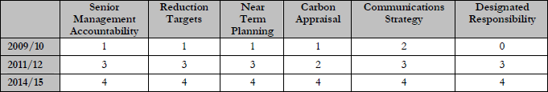
Figure 4.2: Assessment of carbon management by Falkirk Council managers

Air Quality and Climate Change
The measures required to achieve air quality objectives can be in conflict with achieving other objectives and outcomes. The example of climate change is used in this section to show synergies and conflicts but can equally apply to other issues whether environmental or not (e.g. road safety).
In their guidance to local authorities Environmental Protection UK have produced a table illustrating the potential impacts of measures on both air quality and climate change. This table is reproduced in Figure 4.3 and uses the following colours and descriptors:
- Green: The measure generally has a positive impact;
- Amber: The measure may or may not have a negative impact, depending on where or how it is installed;
- Red: The measure generally has a negative impact (although there may be situations where it does not); and
- Neutral: The measure will generally have no significant impact.

As can be seen in Figure 4.3 a significant number of measures, such as alternative fuels, travel plans and car clubs can be beneficial for both air quality and climate change. The measure most likely to give a negative impact for air quality is heat supplied by biomass, with small scale installations potentially causing a greater impact than large scale installations (due to the applicability and viability of abatement equipment). The impacts of measures such as low emission zones and combined heat and power, which are classified as amber, are potentially negative but can be dependent on their design and implementation. A few measures (micro wind turbines and heat pumps) have a neutral classification with no impact on air quality or climate change.
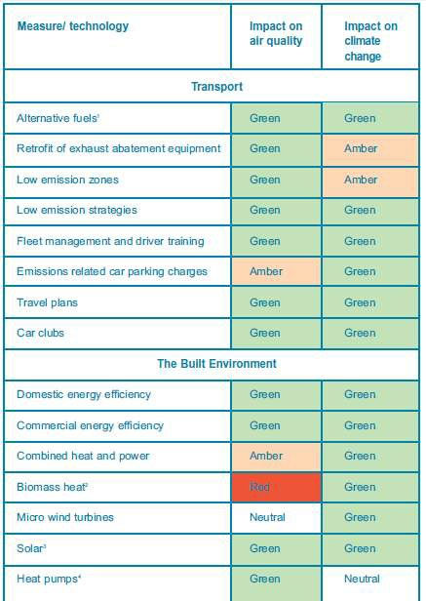
Figure 4.3: An Assessment of the Impact on Air Quality and Climate Change of Various Measures and Technologies

Universal Home Insulation Scheme
Falkirk Council has an on-going commitment towards the promotion of energy conservation and is able to offer home owners free home insulation (i.e. loft and / or cavity insulation), funded by the Scottish Government.
In March 2012 the scheme was extended to include additional private properties in the Falkirk area including: Falkirk Town, Bainsford, Langlees, Camelon, Tamfourhill, Hallglen and Glen Village. Up to 16,000 private properties in Grangemouth, Denny and Bonnybridge are already eligible to receive free loft and/or cavity wall insulation from Falkirk Council following an £800,000 award from the Scottish Government.
The Scottish Boiler Scrappage Scheme offers owner occupiers a voucher entitling them to a £400 subsidy towards the cost of upgrading inefficient boilers with an Energy Saving trust recommended boiler in their property.
These schemes will help to reduce NO_{X} emissions from gas boilers and therefore reduce the background concentrations of NO₂in and around the Air Quality Management Areas.

Home Energy Strategy 2008 - 2011
The main objective of the Home Energy Strategy is to improve the thermal efficiency of the housing stock in the Council area regardless of tenure. Increasing insulation levels not only improves comfort but also reduces energy bills. This strategy ties in with the benefits produced by the universal home insulation scheme. The key aims of the Home energy / fuel poverty strategy are:
      - To meet the energy efficiency criteria set down in the SHQS by 2015 and work towards the eradication of fuel poverty by 2016;
      - To meet the Councils HECA targets;
      - To minimise fuel poverty through income maximisation measures;
      - To maximise the take up of external funding from the main energy suppliers and other sources;
      - To raise awareness of energy efficiency and fuel poverty issues and encourage take up of energy efficiency improvements by home owners and private landlords; and
      - To act as a basis for researching innovative technical solutions to improve home energy efficiency.

Zero Waste Strategy
Falkirk Council is in the process of producing a Zero Waste Strategy for 2012 to 2022 and as part of this has produced a Strategic Environmental Assessment. This document states that the objectives in relation to air quality are proposed to be:
      - Keep air pollution below Local Air Quality Management thresholds;
      - Minimise the adverse impacts of waste management facilities on air quality; and
      - Minimise the amount of vehicle related emission associated with waste management activities.

PLANNED DEVELOPMENTS AFFECTING THEAQMA’S

Falkirk AQMA
The initial Edinburgh to Glasgow Improvement Programme (EGiP) proposals were to provide more frequent trains and the electrification of the Edinburgh to Glasgow (via Falkirk High) railway line. It also included electrification of the line running through Falkirk Grahamston, Camelon and Larbert stations (and onwards to Stirling, Alloa and Dunblane). The revised timetable for the EGiP scheme is reproduced below from the Transport Scotland website:
- December 2013 – Haymarket Station Capacity enhancements open to passengers;
- Summer 2014 –Electrification of Whifflet lines;
- May 2014 –Introduction of electric services on Cumbernauld route;
- December 2016 –Introduction of 7 car electric services on Edinburgh- Glasgow via Falkirk High route;
- December 2016 – Edinburgh Gateway Rail / Tram interchange opens to passengers (by December 2016);

- December 2018 –Electrification of Stirling, Alloa, Dunblane line services with journey time improvements for passengers travelling to Edinburgh or Glasgow;

- December 2018 –42 minute fastest journey time and introduction of 8 car electric services on Edinburgh- Glasgow via Falkirk High route;
- Within CP5 (date TBC) –Redevelopment of Glasgow Queen Street Station; and
- 2019 – Electrification of 75 km of the Shotts Line between Holytown and Midcalder junctions.

Haggs AQMA

Banknock Quarry
In July 2011 Skene Group disposed of their interest in the Cowdenhill Quarry near Banknock, with operations ceasing.
Aggregate Industries have lodged a planning application with North Lanarkshire Council and Falkirk Council for the infill of the Cowdenhill Quarry and the development of the new Tomfyne Quarry. The HGV movements would pass through the Haggs AQMA. The planning application submitted to Falkirk Council was approved on the 30 October 2013.

Residential development
As discussed in Section 4.2.1 various land has been allocated for residential development in the Haggs area. Improvements to the motorway junction infrastructure have been linked to the phased developments of the site. Once two phases of development are completed infrastructure improvements to the junction will be implemented. No date can be placed on these changes at this stage.

ASSESSING AIR QUALITY IMPROVEMENTS
The main aim of the Action Plan is to set out the actions and policies the Council intends to implement to improve air quality within the Falkirk Town Centre and Haggs AQMAs. The action plan considers how the improvement to air quality brought about by the actions and policies contained in the plan will be assessed.

Required Air Quality Improvement
The pollution reduction assessment undertaken as part of the LAQM Further Assessment indicated that a reduction of road traffic related emissions is required to enable compliance with NO₂ air quality objectives at all areas of relevant public exposure within the Falkirk Town Centre AQMA. The level of reduction required is significant at certain sites. The greatest reduction of road NO_{X} is on West Bridge Street, with a 34% reduction in NO_{X} required to meet the objective levels.
The results of the dispersion modelling study undertaken as part of the LAQM Further Assessment for Haggs indicated that the NO₂ annual mean objective of 40 Ig/m³is predicted to be exceeded at ground level locations up to approximately 75 m from the M80 roadside and up to 30 m from the Kilsyth Road close to the roundabout. Modelling of future scenarios accounting for traffic volume growth and reductions in vehicle emissions indicted that a reduction in overall NO₂ concentrations is predicted at most receptors; however reductions are insufficient to enable the NAQS objective for annual mean NO₂ concentrations to be met. A reduction in road traffic emissions via other action plan measures is therefore required to enable future compliance with the NO₂ air quality objective at this location.

Future Requirements for Monitoring
The assessment of the effectiveness of the actions and policies included with the AQAP will be determined through continued monitoring of NO₂ and PM₁₀.
The Council will therefore maintain the current pollutant monitoring network and where resources and necessity arises increase or amend the network to ensure the impact of the AQAP and any new developments affecting the AQMA are covered. The network has most recently been augmented by a PM₁₀ monitor which began operation at the Haggs site in December 2012.

DEVELOPMENT OF THE ACTION PLAN

In-house Steering Group
The development of the Action Plan began with an inception meeting, which was attended by a number of local authority officers. These officers have guided and consulted on the development of the Action Plan through regular steering group meetings. In this way the Action Plan has been influenced by their local knowledge and area of responsibility.
Officers which attended the meetings and / or have been consulted on the action plan include those from:
- Environmental Services –Environmental Health;
- Engineering and Design –Roads and Design;
- Planning and Transport –Development Control and Transport Planning; and
- Fleet Services.
The steering group was formed to provide an appropriate forum for developing the Air Quality Action Plan. The composition of the group was carefully considered to include representatives from all local authority services with an interest in air quality and who may have an influence on the measures being considered within the draft plan.

Action Plan Measures
The actions and policies that the Council intends to implement to reduce pollutant concentrations within the AQMAs have been separated into four categories based on the area of responsibility:
- Transport Planning;
- Fleet Management;
- Environmental Services and Planning; and
- Other Departments and External Agencies.

Fleet Management

Council Vehicles
Improvement of fleet to include hybrid and start stop technology and/or advance date for removal of older vehicles - the Council operates a large fleet of vehicles which has undergone recent upgrade to Euro 4/5 standard. The Council intend to continue to maintain and upgrade their vehicles on a regular basis with a transfer to entirely Euro 5 standard. Approximately 20% of the Council fleet will be replaced over financial years 2014/15 and 2015/16, with 60 new vehicles ordered in 2014/15 alone. Electric Vehicles and Plug-in places
The use of electric vehicles will help to lower pollutant emissions as well as lower CO₂ emissions compared to current fleet vehicles. This will begin to assist Environmental Services in providing leadership in the community through initiating the use of 'greener' vehicles that will be used as part of efforts to monitor and improve air quality levels. The use of electric vehicles will also reduce operational running costs and provide a pilot programme for the Council to consider a wider conversion of vehicles to a greener fleet.
The Council now operate 7 electric vehicles, with charge points at Winchester Avenue, Dalgrain, Municipal Buildings, Earls Road, Abbotsford House.

Eco-driver training for Council Fleet
CPC (Certificate Professional Competence) training for drivers of large vehicles was completed by September 2014.Advanced driver training available for council fleet drivers, to reduce emissions through eco-driving skills, on a service-led basis.

Local fuel stations to provide alternative / green fuels etc.
Council fleet to support local fuel stations in providing alternative / green fuels etc. through contractual or other local schemes.

Transport Planning

Review of School bus contracts (view to raise EURO standards)
Half the present fleet used on school bus contracts is EURO 2. There is currently an 18 year limit in place for the age of vehicles. The review would have to consider the cost implications of reducing the age (increasing the EURO standards) of vehicles as well as other potential costs such as increased fuel consumption.

Improvement of traffic lights at Bankside
A new set of traffic lights have been installed at the junction of Main St and Bankside in February 2012. With Microprocessor Optimised Vehicle Actuation (MOVA) now in use at these lights this should improve the capacity and reduce delays at the junction by about 10%.
Connection of the M9 junction traffic signals has also been considered and implemented. The change has resulted in queuing traffic moving further from receptor locations and free flowing traffic in the vicinity of the receptors. A reduction in measured concentrations has been observed since this change.

Feasibility Study of Haggs infrastructure changes
This would assess the potential for infrastructure changes to be made in and around the AQMAs that would improve the traffic flow and reduce pollutant concentrations. It would also need to take account of potential changes in the Haggs area may occur as a result of planning applications in the area.

Feasibility Study of Falkirk West Bridge Street and Town Centre Traffic Management changes
This would assess the potential for infrastructure changes to be made in and around the AQMAs that would improve the traffic flow and reduce pollutant concentrations. Changes to speed limits, Traffic Regulation Orders (TROs) will be considered in this study. If traffic can become more free flowing in the West Bridge Street area it would be expected that the pollutant levels would reduce.
Initial measures have been undertaken to optimise infrastructure. Recent amendments include new traffic lights at West Bridge Street and Hope Street junction, which are within 250 m of each other and are now linked to optimise traffic flows.
Traffic lights at Kerse Lane are also now MOVA controlled, meaning the traffic light sequencing is adapted to traffic flow conditions, to maximise the throughput of the junction depending on levels of congestion. Three new links of traffic lights have also been installed on Grahams Road link at a cost of ~£500,000.
Further consideration has been undertaken to utilising a SCOOT (Split Cycle Offset Optimisation Technique) system for managing and controlling traffic signals, however the number of small connector roads located within Falkirk Town Centre means that the system would not be suitable.

Take the Right Route
Grangemouth, Larbert and Stenhousemuir make up one of seven areas throughout Scotland which has been chosen to take part in the Scottish Government funded Smarter Choices, Smarter Places initiative, branded locally as Take the Right Route.
Take the Right Route aims to tackle traffic congestion and reduce car dependency by promoting walking, cycling and the use of public transport for every day, short journeys.
The Take the Right Route project covers a wide range of projects in the Larbert and Stenhousemuir area, including:
        - Personal Travel Planning;
        - Marketing and promotion; and
        - Infrastructure improvements.

Personal Travel Planning
Personal Travel Planning (PTP) is a method of engagement that seeks to talk to households to identify their travel needs and issue them with information to help them make informed decisions, such as bus timetables, cycle and walking maps etc. It also has the advantage of talking to members of the public about the issues, challenges and opportunities relating to travel. A green travel map update was issued in 2014.
The PTP project visited to every household in Larbert and Stenhousemuir over two years – each household was visited once in Year 1 and once in Year 2. Three attempts to contact each household were made in each year, with the Travel Advisors visiting each household at different times of the day to engage with the residents.
Through PTP, residents were provided with local travel information, and in Year 2 free ticketing was provided by FirstBus and First Scotrail as an incentive to try public transport. 25 local PTP clinics were also held as part of the project.

The method of visiting the households twice over two years ensured that maximum contact with the target audience – 92% of target households (7,351) were contacted at least once over the two year project. This is the third highest contact rate recorded of a similar size according to Department for Transport (DfT) best practice.
Over the two year period, 4,707 householders participated in at least one wave of PTP, this represents 64% of those contacted and 59% of total target households. This is the third highest level of PTP participation recorded of similar size according to DfT best practice.
Following the intervention in Year One, Travel Advisors in Year Two were able to ask participants if there had been any changes in their travel behaviour. 24% of participating residents reported there had been a positive change in their behaviour (walking, cycling or using public transport more; car sharing and using the car less).
Additional monitoring was undertaken following the second year implementation of PTP. Regular car use increased from 65% to 73%. Regular cycling has increased in Year Two from 10% to 14% and walking has increased from 66% to 74%. Public transport use has also seen an increase in popularity with regular bus travel increasing from 13% to 15% and regular train use from 6% to 10%. Thus, although regular car use has gone up, there have also been similar increases in regular use of sustainable modes.
Although the results show an increase in driving regularly from 62% to 65% in 2010 they also show increases in regular cycling (5% to 10%, walking (48% to 64%), rail use (3% to 6%) and bus use (10% to
13%).
Combining those participants who changed their behaviour over the two year life of the project represents a positive change in travel behaviour over the two year life of the project of between 16% and 18% of the total target households; meaning between 27% and 31% of those participating in the project changed their travel behaviour. 92% of those that changed their travel behaviour stated that PTP influenced this change.

Marketing
Independent market research has been carried out to monitor the effectiveness of the Take the Right Route marketing campaign.
High profile posters and bus wraps have been picked up by the public as good background marketing, and using highly visible sites for publicity has resulted in good brand awareness. This is very important, as awareness is the first step to behaviour change. Awareness raising measures have increased as follows:
        - Awareness of the local brand is up by 50%, the highest of all seven Smarter Choices, Smarter Places towns;
        - Awareness of actions to encourage better use of the car is highest in Larbert and Stenhousemuir, rising from 2% in 2009 to 27% in 2010;
        - Awareness of action to encourage more walking, cycling or bus use increased from 36% in 2009 to 71% in 2010;
        - Total spontaneous awareness of the Take the Right Route campaign has increased from 46% in 2009 to 60% in 2011; and
        - 60% of people can recall campaign messages, with “Walking more” the most recalled message.
Attitudes towards campaign have been extremely positive. 81% of people consider that the campaign is good, with 67% believing the campaign messages to be effective. The majority of people also believe the campaign to be important to the community, relevant, motivating and likeable. In 2011, 57% of people agreed that the campaign has made them consider other means of transport, up from 49% in 2009, with 33% agreeing that they would think about getting hold of information as a result of the campaign.

Overall, 70% of people in 2011 said that the campaign should be continued. This is reflected in Falkirk Council’s successful bid to the Scottish Government to continue the Take the Right Route project in Larbert and Stenhousemuir alongside rolling the project out to other areas, including Grangemouth.
In light of the most recent research, the Take the Right Route campaign will:
        - Continue to emphasise the messages that are resonating well, such as “Leave the car at home for shorter journeys” and will continue to target particular trips;
        - Support the messages by re-emphasising and demonstrating alternative transport options and new infrastructure; and
        - Refresh the campaign to ensure that all materials do not become too familiar.

Scottish Government Results
The Scottish Government carried out independent research and Year One Interim Report has shown:
        - Larbert and Stenhousemuir is the only area which has experienced a significant self-reported net increase in walking – up by 17.7% from 2009 to 2010;
        - Awareness raising activity appears to have made the greatest impact in Larbert and Stenhousemuir, relating to walking and cycling activity and reduced car use;
        - Bicycle ownership has increased most significantly in Larbert and Stenhousemuir, from 44% of households in 2009 to 58% in 2010. Bicycle ownership is highest here out of all seven SCSP towns. It
is possible that this more positive attitude towards cycling may be related to the intensive marketing activity;
        - The net reduction of the frequency of car use as a driver is greatest in Larbert and Stenhousemuir, with a 9.4% reduction since 2009 (self-reported change);
        - Self-reported bus use has risen by 7%;
        - Larbert and Stenhousemuir is one of only two areas (along with Dumfries) to have satisfaction of the community and built environment increase; and
        - The impacts of SCSP are the most visible in Larbert and Stenhousemuir. Although this remains one of the most car dependant towns, people perceive a stronger community and are more aware of
sustainable transport options.

Schools Projects
School travel projects have been running in the Falkirk Council area since 2004, and have formed an important part of the Take the Right Route project. There has been an increase in the number of schools participating in Walk to School projects in May and October, with all primary schools in Larbert and Stenhousemuir now taking part. Regular walking buses are also being held with Kinnaird Primary and Larbert Village Primary.
A cycling transition project has been held at Larbert High School in 2010, 2011and 2012, with another event planned for 2013.
Falkirk Council undertakes two school Hands Up Surveys every year, to monitor how pupils are travelling to school. There has been a marked increase in levels of walking to school in Larbert and Stenhousemuir, which shows the impact of the Take the Right Route project.

Infrastructure Projects
The Take the Right Route project aimed at building on the good network of footways and cycleways in Larbert and Stenhousemuir by completing some key links that were missing in the area. This has included:
        - The Howburn path: a key pedestrian link from South Broomage to the town centre;
        - The Inches path: an upgrade of a path from the Inches to Bellsdyke Road and associated pedestrian island on Bellsdyke Road; and
        - Completing a path from Burns Avenue to Hamilton Road.
Falkirk Council has also installed new cycle storage at a number of community facilities, such as Stenhousemuir Sports Centre, Ochilview Stadium, the town centre and all schools.
A signage audit has also been undertake through Take the Right Route, covering major walking and cycling routes throughout Larbert and Stenhousemuir. Following from this, a network of signs has been provided to all key trip generators, such as the town centre, Forth Valley Royal Hospital and the Central Business Park, to encourage more trips by foot and by bike.

Quality bus corridors
This would require major infrastructure and land acquisition and bus priority measures to be introduced on selected routes. There are some areas, for example Camelon, where land has been reserved for use as bus lanes in the future. Implementation of such schemes will be constrained by funding.

Council Work Travel Plan
This would need to be adopted and implemented Council wide with ownership by senior management. At the current time remote working are mostly ad-hoc and optional.

Bike Hire Scheme
This is considered to be not working well in other pilot areas (excluding London) at present but would remain the option would remain under review.

Soft Measures
Travel planning services would be provided to large employers, schools etc.
Workplace travel plans encourage employees to use alternatives to single occupancy car-use. Such plans could include:
        - Car sharing schemes;
        - Improved facilities to encourage cycling (secure bike parking and showers);
        - Preferential access to reduced price parking for car sharers;
        - Staff bicycles to encourage local journeys to be made sustainably;
        - Flexible working practices such as remote working enabled by remote IT access;
        - Video conferencing;
        - Preferential rate loans to purchase bikes for commuting;
        - Information for staff to encourage green vehicle awareness when purchasing a car; and
        - Changes to mileage allowance.

The use and development of travel plans for all large developments and government buildings will encourage staff and site users to consider the available transport options and provide information on sustainable modes of transport. It is expected that the provision of travel plans will result in a greater up-take of sustainable transport within the region and reduce the number of private vehicle trips.
Soft measures can also include schemes such as the Take the Right Route scheme.

Environmental Services and Planning

Consideration of AQ in Local Development Plan
The Development Control team have a significant role to play in ensuring that planning applications that have the potential to adversely affect air quality, either by introducing receptors to an area of existing poor air quality or by virtue of the development itself leading to an air quality problem, are dealt with appropriately. This is of particular relevance in areas of AQMAs where air quality would then become a material consideration.

Appropriate AQ monitoring in AQMAs
The Council will continue to monitor air quality within the AQMAs and the wider Council area as required by the Review and Assessment process.

ECO Stars Fleet Recognition Scheme
ECO Stars (www.falkirk.gov.uk/ecostars) is a free voluntary scheme designed to provide recognition and guidance on operational best practices to companies operating goods vehicles, buses and coaches. Registration with ECO Stars will be available to companies whose fleet are either based in the Falkirk Council area or spend a significant proportion of time operating in the Council area. The scheme is open to operators of all types of vehicles (LGVs, HGVs, buses and coaches) across all sectors of activity. The scheme aims to improve local air quality and reduce other environmental impacts as well as improving the operational efficiency of vehicles (e.g. fuel efficiency). The scheme is voluntary and is free for operators to join.
In Mid-Devon a trial of the ECO Stars scheme, exclusively for taxis and private hire vehicles, has been conducted. The Falkirk Council scheme has been extended to enable taxis and private hire vehicles to become members of the scheme.

Other Departments and External Agencies

Licensing - Taxi Licensing
The Licensing department should take account of environmental matters when preparing licensing requirements.
In respect of vehicle age Falkirk Council agreed on the 7 May 2013:
“that the current policy on the age of vehicles is changed to reduce the age at which a vehicle can first enter the fleet from 6 years to 3 years but that this is done progressively by a reduction of 1 year each year starting on 1 April 2014 and that the current policy requiring that each new operator licence is in respect of a wheelchair accessible vehicle be modified to the requirement being for a wheelchair accessible vehicle or for a hybrid or electric vehicle;”

Public Transport Provision
The Council is currently considering its policy with respect to the implementation of measures under the Public Service Vehicle Amendments Regulations 2008. At present, it is anticipated that the introduction of Traffic Regulation Conditions for the purposes of reducing emissions from buses would lead to a reduction in the number of service operators and vehicles operating. Accordingly, it is considered that the reduced service to the public may outweigh any air quality benefits. The Council will continue to review its position in this regard.

The tendered network is scheduled for revision in 2015, in line with the outlined tendering process and to account for commercial network changes. The Council are currently considering how to incorporate Ecostars membership into the tendering process. Additional options will also be included in the process considering the use of newer vehicles with reduced emissions but with anticipated higher tender price.

Falkirk and West Lothian Councils - Vehicle Emissions Partnership

Vehicle Idling
Idling engines cause unnecessary pollution, create noise and waste fuel. The Council have adopted road transport regulations⁴ to help to improve local air quality. The Council intend to raise awareness about the impact of idling engines through targeted campaigns to specific categories of drivers or in areas where vehicles are found idling unnecessarily (and responding to complaints from the public) such as taxi ranks and school pick-up areas where significant pollution might coincide with public exposure.
The Council currently has powers to enforce and issue fines to owners of vehicles which continue to use their engines whilst parked but currently the Council have opted for an educational message only and not issue fines. The Council will continue to utilise these powers to reduce the presence of idling vehicles within the AQMA.

Vehicle Emissions Testing
Road traffic emissions vary from vehicle to vehicle and each vehicle category has standards which it is required to meet. Vehicle emissions are assessed as part of the MOT process and can be checked through roadside monitoring. Generally older vehicles and those that do not receive regular servicing will have the potential to emit pollutants at significant levels and in an attempt to address this, the Council undertakes vehicle emission testing as part of an educational programme rather than fining.

Developers – Work place travel plans and car clubs
Workplace travel plans encourage employees to use alternatives to single occupancy car-use. Such plans could include:
        - Car sharing schemes;
        - Improved facilities to encourage cycling (secure bike parking and showers);
        - Preferential access to reduced price parking for car sharers;
        - Staff bicycles to encourage local journeys to be made sustainably;
        - Flexible working practices such as remote working enabled by remote IT access;
        - Video conferencing;
        - Preferential rate loans to purchase bikes for commuting;
        - Information for staff to encourage green vehicle awareness when purchasing a car; and
        - Changes to mileage allowance.
The use and development of travel plans for all large developments and government buildings will encourage staff and site users to consider the available transport options and provide information on sustainable modes of transport. It is expected that the provision of travel plans will result in a greater up-take of sustainable transport within the region and reduce the number of private vehicle trips. Implementation of such measures for new developments will be encouraged via Section 75 agreements through the planning process.

⁴Road Vehicles (Construction and Use) Act and The Road Traffic (Vehicle Emissions) (Scotland) Regulations 2002

Measures Considered But Not Included in Action Plan
Several additional measures were considered at the initial steering group meetings which after initial screening by the group were discounted for a variety of reasons. Further information on these measures and the reasons for their exclusion can be found in Appendix A.

Evaluation of Action Plan Measures
Scottish Government requires Local authorities to prioritise measures they have identified within their action plans on effectiveness, feasibility, proportionate and quantifiable measures. A simple cost benefit analysis has been carried out.
In accordance with the government guidance, the measures short-listed for inclusion within the action plan have been assessed against a wide range of criteria in order to assess their suitability for inclusion within the plan and enable suitable measures to be prioritised.
The criteria against which options were assessed were:
- Implementation costs;
- Air Quality Benefit;
- Potential co-environmental benefits, risk factors, social impacts and economic impacts; and
- Perception and practicability.

Air Quality Benefit
This is a key assessment in that the AQAP must focus on prioritising options that improve air quality most effectively. The assessment is complex in that the detailed assessment of any given option could normally be subject to a study of its own requiring significant resources.
A semi-quantitative assessment, relying on a level of judgement has been adopted. The method used is outlined below:
- The description of the option and the proposed change to be brought about by the option is used alongside the source apportionment analysis (Chapter 3) to define what proportion of emissions would
potentially be affected by the action plan measure;
- The proportion of emissions potentially affected by the option and the view on how far they could be changed by the option are combined to express a view on how much emissions may be reduced in the
AQMA due to the action plan measure; and
- A view is then expressed on how significant this change in emissions would be in terms of making progress towards the air quality standard in the AQMA.
For the purpose of the AQ assessment the result of the air quality benefit has been assessed as having a potentially:
- Low local AQ benefit equals 1% improvement;
- Medium local AQ benefit equals 2-5%; and
- Large local AQ benefit equals >5%.
Air Quality benefit has been presented using the following key.

Table 7.1: Air Quality Benefit Key
Air Quality improvement | Symbol
Low | ✓
Medium | ✓✓
High | ✓✓✓

It should be noted that the precise improvement in air quality attributable to each measure cannot be accurately quantified at this stage. The appraisal of air quality benefit has therefore been determined based on professional judgement and with reference to the work undertaken as part of the Further Assessment.

Implementation Costs
The potential implementation costs of each option are assessed as follows:
- No cost – measure already implemented through existing plans / programmes;
- Low costs – up to £50k e.g. for small surveys or campaigns or other options using current resources;
- Medium costs – £50k to £500k e.g. for a full time officer and resources to traffic management schemes; and
- High costs – above £500k annually e.g. for new infrastructure.
No accurate estimates of the costs to implement the Action Plan measures have been made at this stage. The implementation costs have therefore been estimated based on professional judgement in consultation with relevant Council officers.

Potential Co-environmental Benefits
In this assessment other environmental benefits are highlighted:
- Greenhouse gases: The likely effect on greenhouse gas emissions is assessed as being an overall reduction or a local reduction perhaps with emissions being relocated elsewhere;
- Health and wellbeing;
- Air Quality awareness;
- Noise; and
- Long term financial benefit.
The potential co-benefits have been identified in discussion with relevant Council officers. If required a Strategic Environmental Assessment (SEA) of the finalised Action Plan will be undertaken to identify potential co-benefits and/or conflicts with other environmental and social aspects.

Perceptions and Practicability
In this assessment the perception and practicability were assesses by considering the following:
- The executive powers under existing legislation to implement and enforce a measure. Alternatively, whether the Council has an existing mechanism to influence other agencies to implement a measure;
- Secured funding for the measure or a straightforward route for securing funding; and
- Characterise the potential positive and negative impacts of the measure with sufficient evidence or confidence to make a decision to implement the measure.

Table 7.2: Cost Benefit Analysis of Action Plan Measures
Action |  | Responsibility | Timescale Current  Short Term 1-2 yrs. Medium 3-5 yrs.  Long Term +5yrs | Cost to Council Low < £50K  Medium £50K - £500K  High >£500K Source of funding | Air Quality Benefit Low  Medium  High  For PM10& NO2 (either combined or  individually) | Non-Air Quality Impacts | Perceptions & Practicability
1 | Council Vehicles, e.g. Advance date for removal of older  vehicles | Fleet management | Long Term | High  Capital Budget & Transport Scotland | ✓✓ | Reduced CO2 | Achievable through move to EURO 5 / 6 standard engines
2 | Electric Vehicles and Plug-ins | Fleet Management (for Council fleet) | Long Term | High  Capital Budget & Transport Scotland | ✓ | Reduced CO2 & vehicle safety | Practical throughout much of current fleet – Costly change of vehicles and  infrastructure
3 | Eco/ advanced driver training | Fleet management | Short-term | Low | ✓ | Staff will have cost benefit through better fuel economy | CPC in place for large vehicles by 2013.  SEStran leaflets
 |  |  |  |  |  | Possibly reduced
 |  |  |  |  |  | running costs for
4 | Support local fuel stations to provide alternative / green fuels chargers etc. | Fleet management (Council fleet) | Long-term | Low if just awareness etc. | ✓ | vehicles. Unexpected impacts, e.g. with biofuels.  Opportunity to | Good, if lower costs
 |  |  |  |  |  | tender for fleet fuel
 |  |  |  |  |  | suppliers

Action |  | Responsibility | Timescale Current  Short Term 1-2 yrs. Medium 3-5 yrs.  Long Term +5yrs | Cost to Council Low < £50K  Medium £50K - £500K  High >£500K Source of funding | Air Quality Benefit Low  Medium  High  For PM10& NO2 (either combined or  individually) | Non-Air Quality Impacts | Perceptions & Practicability
5 | Review of school bus contracts with view to raising EURO standards | Transport Planning Unit | Long term | High | ✓✓ Major reduction in fuel economy | Improved safety. Would be a financial burden to current bus companies | Half the present fleet is EURO 2. Remainder would have to be upgraded. 18 year  limit in place
6 | Improvements of traffic lights at Bankside | Transport Planning Unit and Engineering  Design Unit | Current | Medium cost (£150k) | ✓✓ Improves efficiency and flow through traffic signals thus improving air quality | Improves access to the town centre and reduces congestion | Noticeable improvements in journey times
7 | Feasibility study of Haggs infrastructure changes | Transport Planning Unit and Development Management | Medium to long term | High  Developer funded | ✓✓ Reduces congestion thus improving air quality | Improves access to the trunk road network | Will be required to militate against impact of proposed developments in the  area
8 | Feasibility study of West Bridge Street and Town Centre traffic management changes (speed limits, TROs  etc.) | Transport Planning Unit / Roads | Long term | High | ✓✓✓ | Reduced congestion | 2004-05 report done, Transport Planning Unit to forward
9 | Take the Right Route | Transport Planning Unit | Short | Dependent on Scottish Government funding. | - Equipment not currently refined enough to measure benefits. Impacts will be noticeable over time | Reducing car usage, improvements in health and  wellbeing | Current data shows positive results for schools businesses and the wider  community

Action |  | Responsibility | Timescale Current  Short Term 1-2 yrs. Medium 3-5 yrs.  Long Term +5yrs | Cost to Council Low < £50K  Medium £50K - £500K  High >£500K Source of funding | Air Quality Benefit Low  Medium  High  For PM10& NO2 (either combined or  individually) | Non-Air Quality Impacts | Perceptions & Practicability
10 | Council Service based work travel plan | Falkirk Council and the Transport Planning Unit | Current | Low | - Impacts will be noticeable over time | Reducing car usage and single car occupancy for Council employees | Has to be adopted and implemented Council wide with ownership by senior management  Remote working  mainly ad-hoc & optional
11 | Introduce quality bus corridors | Transport Planning Unit | Long term | High | - Noticeable over time | Reduction in car usage and congestion | Requires major infrastructure and land acquisition and bus priority measures to be  introduced on selected routes
12 | Bike hire scheme | Transport Planning Unit | Long term | Medium | Unknown | Improvement to health and  wellbeing | Not working well in other pilot areas at  present
13 | Soft measures e.g. travel planning (large employers, schools), journey sharing, changes to mileage,  home & mobile working | Transport Planning Unit / Schools / Developers | Current | Medium  (low for individual projects) | - Equipment not currently refined enough to measure benefits. Impacts will be noticeable over time | Reducing car usage, improvements in health and wellbeing | Current data shows positive results for schools businesses and the wider community
14 | Consideration of air quality in local development plan. | Environmental Services & Planning | Medium to long. | Low | - Varies | Impact on other planning considerations. | Local Transport Strategy also considers air quality

Action |  | Responsibility | Timescale Current  Short Term 1-2 yrs. Medium 3-5 yrs.  Long Term +5yrs | Cost to Council Low < £50K  Medium £50K - £500K  High >£500K Source of funding | Air Quality Benefit Low  Medium  High  For PM10& NO2 (either combined or  individually) | Non-Air Quality Impacts | Perceptions & Practicability
15 | Appropriate air quality monitoring in AQMAs | Environmental Services | Variable. | Medium | Required for process | n/a | n/a
16 | Promotion of ECO Stars | Environmental Services | Short to medium | Low | - Variable | Reduced fuel consumption and vehicle safety. | Could be positive if reduction in costs / improved revenues
17 | Review of park and ride facilities | SEStran | Current | Low | - Noticeable over time | Reduction in car  usage easing congestion | Current high  perception for railway stations
18 | Taxi licensing | Licensing | Short to medium | Low, medium to high in particular locations. | ✓ to ✓✓ | Improved safety if  newer vehicles used | Depends on exact proposals
19 | Vehicle Emissions Partnership (testing & idling) - enforcement & fines rather than raising awareness. | Falkirk and West Lothian Councils | Dependent on funding | Low.  West Lothian co- ordinate, Scottish Government funding |  | Reduced fuel use | Awareness probably welcome, enforcement different issue
20 | Introduction of car clubs. | Developers | Long term | Nil | - Noticeable over time | Reduction in car ownership and use easing possible  future congestion | Not many schemes available to compare against

CONSULTATION ON DRAFT ACTION PLAN MEASURES
A Consultation Exercise was undertaken on the draft Action Plan in 2013. The Consultation included neighbouring Local Authorities, public bodies such as Transport Scotland, NHS Forth Valley and Scottish Natural Heritage, as well as Community Council groups for affected areas i.e. Banknock and Haggs Community Council.One response was received from Banknock Community Council but concerned another AQMA. No significant changes were required to the draft Action plan.
In addition, a public consultation was conducted between the 21 June and 28 August 2013. The draft Action Plan was available for comments either at the following locations or via the following methods:
    - On the Falkirk Council website in the ‘Have Your Say’ and Air Quality sections;
    - Summary poster and document available at Bonnybridge Library, Municipal Buildings (Falkirk) and Abbotsford House (Bainsford);
    - Email to known relevant parties or organisations; and
    - An online survey.
Five responses to the online questionnaire and one email response were received to the consultation. The email response gave comments that were mostly related to another AQMA and thus it was considered that no significant changes were required to the draft Action Plan.

CONCLUSIONS
The Local Air Quality Management process has resulted in Falkirk Council declaring two road traffic related Air Quality Management Areas. The Falkirk Town Centre AQMA was declared in relation to breaches of the NO₂ annual objective and the Scottish PM₁₀ objectives, while the Haggs AQMA is currently for the NO₂ annual objective only (with PM₁₀ monitoring currently being conducted).
This draft Action Plan has been developed with measures that aim to ensure that the objectives are achieved in the two road traffic AQMAs. Several measures of the draft Action Plan are already underway such as the vehicle emissions partnership, with West Lothian Council, and the Falkirk ECO Stars scheme for commercial vehicle operators. The measures can be classed into the following groups:
    - Reducing emissions from individual vehicles;
    - Promotion of the Falkirk ECO Stars scheme for commercial vehicle operators;
    - Planning and development measure;
    - Reducing demand for travel and promoting alternative modes of transport; and
    - Educating and informing the public regarding air quality.
The LAQM process will require air quality monitoring to continue in the two AQMAs. The monitoring results will be reported to the Scottish Government in subsequent Progress Reports and Updating and Screening Assessments (or their replacement). The monitoring results will play a role in assessing the effectiveness of the draft Action Plan. The principal monitoring stations for this purpose are the Falkirk West Bridge Street and Haggs sites. It is noted though that concentrations are also dependent on emissions from other areas and countries, actions by other organisations and meteorological conditions.
With the successful implementation of the measures in the draft Action Plan and the subsequent reductions in concentrations to below the air quality objectives an Air Quality Management Area can be revoked.

Report Signature Page

GOLDER ASSOCIATES (UK) LTD

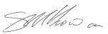

Stuart McGowan
Senior EIA, Air and Noise Consultant

Date: 5 June 2015 JS/SMcG/te
Company Registered in England No.1125149.
At Attenborough House, Browns Lane Business Park, Stanton-on-the-Wolds, Nottinghamshire NG12 5BL VAT No. 209 0084 92
Golder, Golder Associates and the GA globe design are trademarks of Golder Associates Corporation.

APPENDIX A
Potential Action Plan Measures no Longer Included in the AQAP



Golder Associates (UK) Ltd Sirius Building, The Clocktower South Gyle Crescent Edinburgh
EH12 9LB UK
T: [+44] (0) 131 314 5900

